**6.0 System Design**

**6.1 Design Strategies**

The proposed system is designed to the MVC model. For the interface design, Boostrap and CSS was used. The interface provides set of controls and action tools that allows interactivity of the web pages of the system. The interface is also designed to have the necessary details for better user experience.

The programming language used for the system is Java and uses Apache Tomcat for the server. JDBC library is used to connect to the database MySQL.

Highcharts was the tool used to generate and display interactive charts inside the webpages. This tool offers different kinds of charts and is highly customizable.

The formula used for the forecasting was Multiple Linear Regression. The formula is as follows:

yi=β0+β1xi,1+β2xi,2+…+βp−1xi,p−1+ϵi.

Y indicates the dependent variable which is the value to be predicted/forecasted. β0 are the independent variable or the predictors that will affect the value of the dependent variable. An example would be the forecasting the future harvest or crop estimate. The Tons Cane or the production is the value we are looking for. Then the parameters that are needed according to the expert would be the area for harvest, rainfall, tiller count, and average temperature. These predictors will used in the formula along with the actual production. The actual production will be used to check how much is the difference with the forecasted value.

**6.2 Data Specifications**

**6.2.1 ERD**

**6.2.2 Tables/Layouts**

AGP

|  |  |  |  |
| --- | --- | --- | --- |
| Column Name | Description | Data Type (Length) | Values |
| year | crop year | INT | NUMERIC |
| district | district name | VARCHAR(45) | ALPHA-NUMERIC |
| municipality | municipality in district | VARCHAR(45) | ALPHA-NUMERIC |
| barangay | barangay in the municipality | VARCHAR(45) | ALPHA-NUMERIC |
| area | area harvested | DECIMAL(10) | NUMERIC |
| tons_cane | cane produced | DECIMAL(10) | NUMERIC |
| Lkg | sugar produced | DECIMAL(10) | NUMERIC |

AnnualCropEstimate

|  |  |  |  |
| --- | --- | --- | --- |
| Column Name | Description | Data Type (Length) | Values |
| year | crop year | INT | NUMERIC |
| district | district name | VARCHAR(45) | ALPHA-NUMERIC |
| area | area harvested | DECIMAL(10) | NUMERIC |
| tons_cane | cane produced | DECIMAL(10) | NUMERIC |
| Lkg | sugar produced | DECIMAL(10) | NUMERIC |

CommentScoreFarmers

|  |  |  |  |
| --- | --- | --- | --- |
| Column Name | Description | Data Type (Length) | Values |
| Farmers_name | farmer name | VARCHAR(45) | ALPHA-NUMERIC |
| Comments_id | id of comments | INT | NUMERIC |

CommentScoreUsers

|  |  |  |  |
| --- | --- | --- | --- |
| Column Name | Description | Data Type (Length) | Values |
| Users_username | username | VARCHAR(45) | ALPHA-NUMERIC |
| Comments_id | id of comments | INT | NUMERIC |

Comments

|  |  |  |  |
| --- | --- | --- | --- |
| Column Name | Description | Data Type (Length) | Values |
| id | table id | INT | NUMERIC |
| Posts_id | id of posts | INT | NUMERIC |
| Farmers_Name | name of farmer | VARCHAR(45) | ALPHA-NUMERIC |
| Message | message for posting | TEXT | ALPHA-NUMERIC |
| recommended | recommendation | CHAR | ALPHA-NUMERIC |
| Date | date posted | DATE |  |

Configuration

|  |  |  |  |
| --- | --- | --- | --- |
| Column Name | Description | Data Type (Length) | Values |
| Date | date for configuration | DATE |  |

CropAssessment

|  |  |  |  |
| --- | --- | --- | --- |
| Column Name | Description | Data Type (Length) | Values |
| year | crop year | INT | NUMERIC |
| district | district name | VARCHAR(45) | ALPHA-NUMERIC |
| week_ending | last day of the week | DATE |  |
| weather | weather report for the week | TEXT | ALPHA-NUMERIC |
| prices_of_sugar | price update | TEXT | ALPHA-NUMERIC |
| mill_operation | mill operation updates | TEXT | ALPHA-NUMERIC |
| prices_of_inputs | price updates of fertilizers and other farming tools | TEXT | ALPHA-NUMERIC |
| others | other reports | TEXT | ALPHA-NUMERIC |
| overall_analysis | analysis for the week | TEXT | ALPHA-NUMERIC |

CropEstimateDistrict

|  |  |  |  |
| --- | --- | --- | --- |
| Column Name | Description | Data Type (Length) | Values |
| district | name of district | VARCHAR(45) | ALPHA-NUMERIC |
| area | area harvested | DECIMAL(10,3) | NUMERIC |
| rainfall | amount of rainfall | DECIMAL(10,3) | NUMERIC |
| actual_tons_cane | actual cane produced | DECIMAL(10,3) | NUMERIC |
| tiller_count | tiller count | DECIMAL(10,3) | NUMERIC |
| avg_temperature | average temperature of district | DECIMAL(10,3) | NUMERIC |
| forecasted1 | 1st forecast value | DECIMAL(10,3) | NUMERIC |
| forecasted2 | 2nd forecast value | DECIMAL(10,3) | NUMERIC |
| forecasted3 | 3rd forecast value | DECIMAL(10,3) | NUMERIC |
| forecasted_lkg1 | 1st forecast value | DECIMAL(10,3) | NUMERIC |
| forecasted_lkg2 | 2nd forecast value | DECIMAL(10,3) | NUMERIC |
| forecasted_lkg3 | 3rd forecast value | DECIMAL(10,3) | NUMERIC |

CropEstimateDistrictTest

|  |  |  |  |
| --- | --- | --- | --- |
| Column Name | Description | Data Type (Length) | Values |
| district | name of district | VARCHAR(45) | ALPHA-NUMERIC |
| area | area harvested | DECIMAL(10,3) | NUMERIC |
| rainfall | amount of rainfall | DECIMAL(10,3) | NUMERIC |
| actual_tons_cane | actual cane produced | DECIMAL(10,3) | NUMERIC |
| tiller_count | tiller count | DECIMAL(10,3) | NUMERIC |
| avg_temperature | average temperature of district | DECIMAL(10,3) | NUMERIC |
| forecast1 | 1st forecast value | DECIMAL(10,3) | NUMERIC |
| forecast2 | 2nd forecast value | DECIMAL(10,3) | NUMERIC |
| forecast3 | 3rd forecast value | DECIMAL(10) | NUMERIC |
| forecast_1lkg | 1st forecast value | DECIMAL(10) | NUMERIC |
| forecast_2lkg | 2nd forecast value | DECIMAL(10) | NUMERIC |
| forecast_3lkg | 3rd forecast value | DECIMAL(10) | NUMERIC |

CropEstimateMuncipality

|  |  |  |  |
| --- | --- | --- | --- |
| Column Name | Description | Data Type (Length) | Values |
| year | crop year | INT | NUMERIC |
| district | name of district | VARCHAR(45) | ALPHA-NUMERIC |
| municipality | municipality in district | VARCHAR(45) | ALPHA-NUMERIC |
| area | area harvested | DECIMAL(10) | NUMERIC |
| tons_cane | cane produced | DECIMAL(10) | NUMERIC |
| avg_temperature | average temperature of district | DECIMAL(10) | NUMERIC |
| forecasted | forecasted value | DECIMAL(10) | NUMERIC |

CropStages

|  |  |  |  |
| --- | --- | --- | --- |
| Column Name | Description | Data Type (Length) | Values |
| phase | phases of crop growth | VARCHAR(45) | ALPHA-NUMERIC |

CropValidationSurvey

|  |  |  |  |
| --- | --- | --- | --- |
| Column Name | Description | Data Type (Length) | Values |
| year | crop year | INT | NUMERIC |
| Fields_id | id of farm | INT | NUMERIC |
| variety | variety of cane | VARCHAR(45) | ALPHA-NUMERIC |
| crop_class | crop class of cane | VARCHAR(45) | ALPHA-NUMERIC |
| texture | texture of soil | VARCHAR(45) | ALPHA-NUMERIC |
| farming_system | farming system of farm | VARCHAR(45) | ALPHA-NUMERIC |
| topography | topography of land | VARCHAR(45) | ALPHA-NUMERIC |
| furrow_distance | furrow distance of farm | DECIMAL(7) | NUMERIC |
| planting_density | farm land density | DECIMAL(10) | NUMERIC |
| num_millable | number of millable cane stalks | INT | NUMERIC |
| avg_millable_stool | average millable stool | DECIMAL(7) | NUMERIC |
| brix | brix reading of cane | DECIMAL(7) | NUMERIC |
| stalk_length | length of cane stalk | DECIMAL(7) | NUMERIC |
| diameter | diameter of stalk | DECIMAL(7) | NUMERIC |
| weight | weight of stalk | DECIMAL(7) | NUMERIC |

Crop_Calendar

|  |  |  |  |
| --- | --- | --- | --- |
| Column Name | Description | Data Type (Length) | Values |
| year | crop year | INT | NUMERIC |
| district | district name | VARCHAR(45) | ALPHA-NUMERIC |
| phase | phase of crop growth | VARCHAR(45) | ALPHA-NUMERIC |
| date_starting | starting date of phase | DATE |  |

DashboardData

|  |  |  |  |
| --- | --- | --- | --- |
| Column Name | Description | Data Type (Length) | Values |
| id | table id | INT | NUMERIC |
| year | crop year | INT | NUMERIC |
| district | name of district | VARCHAR(45) | ALPHA-NUMERIC |
| week_ending | last day of the week | DATE |  |
| area | area harvested | DECIMAL(10) | NUMERIC |
| actual | actual cane produced | DECIMAL(10) | NUMERIC |
| lkg | sugar produced | DECIMAL(10) | NUMERIC |
| rainfall | amount of rainfall | DECIMAL(10) | NUMERIC |
| forecasted | forecasted cane produced | DECIMAL(10) | NUMERIC |

DisasterAlerts

|  |  |  |  |
| --- | --- | --- | --- |
| Column Name | Description | Data Type (Length) | Values |
| id | table id | INT | NUMERIC |
| Problems_id | id of problems | INT | NUMERIC |
| message | message to be sent | TEXT | ALPHA-NUMERIC |
| date | date of disaster | DATE |  |
| barangay | barangay affected by disaster | VARCHAR(45) | ALPHA-NUMERIC |
| district | name of district | VARCHAR(45) | ALPHA-NUMERIC |
| municipality | municipality in district | VARCHAR(45) | ALPHA-NUMERIC |

Farmers

|  |  |  |  |
| --- | --- | --- | --- |
| Column Name | Description | Data Type (Length) | Values |
| name | name of farmer | VARCHAR(45) | ALPHA-NUMERIC |
| username | username of farmer | VARCHAR(12) | ALPHA-NUMERIC |
| password | password of account | TEXT | ALPHA-NUMERIC |
| district | name of district | VARCHAR(45) | ALPHA-NUMERIC |

Fertilizers

|  |  |  |  |
| --- | --- | --- | --- |
| Column Name | Description | Data Type (Length) | Values |
| year | crop year | INT | NUMERIC |
| Fields_id | id of fields | INT | NUMERIC |
| fertilizer | fertilizer used | VARCHAR(45) | ALPHA-NUMERIC |
| first_dose | first dose of fertilizer | DECIMAL(7) | NUMERIC |
| second_dose | second dose of fertilizer | DECIMAL(7) | NUMERIC |

Fields

|  |  |  |  |
| --- | --- | --- | --- |
| Column Name | Description | Data Type (Length) | Values |
| id | table id | INT | NUMERIC |
| Farmers_name | name of farmer | VARCHAR(45) | ALPHA-NUMERIC |
| area | area of farm | DECIMAL(6) | NUMERIC |
| boundary | boundary of each farm | TEXT | ALPHA-NUMERIC |
| barangay | barangay of the field | VARCHAR(45) | ALPHA-NUMERIC |
| district | name of district | VARCHAR(45) | ALPHA-NUMERIC |
| municipality | municipality in district | VARCHAR(45) | ALPHA-NUMERIC |

HistoricalCVS

|  |  |  |  |
| --- | --- | --- | --- |
| Column Name | Description | Data Type (Length) | Values |
| name | name of farmer | VARCHAR(45) | ALPHA-NUMERIC |
| district | name of district | VARCHAR(45) | ALPHA-NUMERIC |
| barangay | barangay in the municipality | VARCHAR(45) | ALPHA-NUMERIC |
| municipality | municipality in district | VARCHAR(45) | ALPHA-NUMERIC |
| texture | soil texture | VARCHAR(45) | ALPHA-NUMERIC |
| crop_class | crop class of cane | VARCHAR(45) | ALPHA-NUMERIC |
| topography | topography of land | VARCHAR(45) | ALPHA-NUMERIC |
| furrow_distance | furrow distance of farm | DECIMAL(7) | NUMERIC |
| tiller_count | number of tillers | DECIMAL(10) | NUMERIC |
| variety | variety of cane | VARCHAR(45) | ALPHA-NUMERIC |
| brix | brix reading of cane | DECIMAL(7) | NUMERIC |
| diameter | diameter of stalk | DECIMAL(7) | NUMERIC |
| weight | weight of stalk | DECIMAL(7) | NUMERIC |

Historical Production

|  |  |  |  |
| --- | --- | --- | --- |
| Column Name | Description | Data Type (Length) | Values |
| id | table id | INT | NUMERIC |
| Farmers_name | name of farmer | VARCHAR(45) | ALPHA-NUMERIC |
| date | date of production | DATE | ALPHA-NUMERIC |
| lkg | sugar produced | DECIMAL(10,3) | NUMERIC |
| barangay | barangay production | VARCHAR(45) | ALPHA-NUMERIC |
| municipality | municipality in district | VARCHAR(45) | ALPHA-NUMERIC |
| district | name of district | VARCHAR(45) | ALPHA-NUMERIC |
| year | crop year | INT | NUMERIC |
| area | area harvested | DECIMAL(10,3) | NUMERIC |
| tons_cane | cane produced | DECIMAL(7) | NUMERIC |

KPIs

|  |  |  |  |
| --- | --- | --- | --- |
| Column Name | Description | Data Type (Length) | Values |
| year | crop year | INT | NUMERIC |
| Program_name | name of program | VARCHAR(45) | ALPHA-NUMERIC |
| name | name of kpi | VARCHAR(255) | ALPHA-NUMERIC |
| value | target value for kpi | DECIMAL(10,3) | NUMERIC |
| actual | current value for kpi | DECIMAL(10,3) | NUMERIC |

MediaFile

|  |  |  |  |
| --- | --- | --- | --- |
| Column Name | Description | Data Type (Length) | Values |
| id | table id | INT | NUMERIC |
| Posts_id | id of posts | INT | NUMERIC |
| img_url | file path of image file | TEXT | ALPHA-NUMERIC |

Monthly Surveys

|  |  |  |  |
| --- | --- | --- | --- |
| Column Name | Description | Data Type (Length) | Values |
| Fields_id | id of field | INT | NUMERIC |
| stalk_length | length of the stalk | DECIMAL(7,3) | NUMERIC |
| month | month of the crop year | INT | ALPHA-NUMERIC |
| internodes_u | internodes of the stalk | DECIMAL(10,3) | NUMERIC |
| internodes_i | internodes of the stalk | DECIMAL(10,3) | NUMERIC |
| stalk_diameter_u | diameter of the stalk | DECIMAL(10,3) | NUMERIC |
| stalk_diameter_i | diameter of the stalk | DECIMAL(10,3) | NUMERIC |
| year | crop year | INT | NUMERIC |
| img_url | file path of the image | TEXT | ALPHA-NUMERIC |

Notifications

|  |  |  |  |
| --- | --- | --- | --- |
| Column Name | Description | Data Type (Length) | Values |
| id | table id | INT | NUMERIC |
| disaster | disaster alert | CHAR | ALPHA-NUMERIC |
| received | received notification from disaster alert | CHAR | ALPHA-NUMERIC |
| Fields_id | id of the field | INT | NUMERIC |
| message | message to be sent | TEXT | ALPHA-NUMERIC |
| date | date of the notification | DATE |  |
| Disaster_alerts_id | id of the disaster aler | INT | NUMERIC |
| Problem_Fields_id | id of the problem fields | INT | NUMERIC |
| Posts_id | id of the post | INT | NUMERIC |
| Recommendations_id | id of the recommendation | INT | NUMERIC |
| Recommendations_Fields_id | id of the recommendation | INT | NUMERIC |

Post_Status

|  |  |  |  |
| --- | --- | --- | --- |
| Column Name | Description | Data Type (Length) | Values |
| status | status of the post | VARCHAR(45) | APLHA-NUMERIC |

Posts

|  |  |  |  |
| --- | --- | --- | --- |
| Column Name | Description | Data Type (Length) | Values |
| id | table id | INT | NUMERIC |
| title | title of the post | VARCHAR(45) | ALPHA-NUMERIC |
| Fields_id | id of the post | INT | NUMERIC |
| message | message of the post to be sent | TEXT | ALPHA-NUMERIC |
| date_posted | date posted | DATE |  |
| date_started | date start of the post | DATE |  |
| Problem_ id | id of the problems | INT | NUMERIC |
| date_ended | end date of the post | DATE |  |
| Recommendations_id | id of the recommendation | INT | NUMERIC |
| status | status of the post | VARCHAR(45) | ALPHA-NUMERIC |

Problems_Types

|  |  |  |  |
| --- | --- | --- | --- |
| Column Name | Description | Data Type (Length) | Values |
| type | types of problems | VARCHAR(45) | ALPHA-NUMERIC |

Problems

|  |  |  |  |
| --- | --- | --- | --- |
| Column Name | Description | Data Type (Length) | Values |
| id | table id | INT | NUMERIC |
| name | name of the problem | VARCHAR(45) | ALPHA-NUMERIC |
| type | type of problem | VARCHAR(45) | ALPHA-NUMERIC |
| description | details of the problem | TEXT | ALPHA-NUMERIC |
| date | date of the problem | DATE |  |
| phase | crop phase where the problem occurred/occurs | VARCHAR(45) | ALPHA-NUMERIC |

Problem-Fields

|  |  |  |  |
| --- | --- | --- | --- |
| Column Name | Description | Data Type (Length) | Values |
| id | table id | INT | NUMERIC |
| Problems_id | id of the problem | INT | NUMERIC |
| Fields_id | id of the fields | INT | NUMERIC |
| status | status of the problem | VARCHAR(45) | ALPHA-NUMERIC |
| date | date the problem occurred | DATE |  |
| damage | damage done by the problem | DECIMAL(6,3) | NUMERIC |

ProblemsMedia

|  |  |  |  |
| --- | --- | --- | --- |
| Column Name | Description | Data Type (Length) | Values |
| id | table id | INT | NUMERIC |
| problem_id | id of the problem | INT | NUMERIC |
| img_url | file path of the image | TEXT | ALPHA-NUMERIC |

Production

|  |  |  |  |
| --- | --- | --- | --- |
| Column Name | Description | Data Type (Length) | Values |
| id | table id | INT | NUMERIC |
| year | crop year | INT | NUMERIC |
| Fields_id | id of the field | INT | NUMERIC |
| area_harvested | harvested area | DECIMAL(10,4) | NUMERIC |
| tons_cane | cane produced | DECIMAL(10,4) | NUMERIC |
| date | date of production | DATE |  |
| lkg | sugar produced | DECIMAL(10,4) | NUMERIC |

Programs

|  |  |  |  |
| --- | --- | --- | --- |
| Column Name | Description | Data Type (Length) | Values |
| name | name of the program | VARCHAR(45) | ALPHA-NUMERIC |
| date_created | date the program was created | DATE |  |
| date_intial | initial starting date of the program | DATE |  |
| date_end | end date of the program | DATE |  |
| description | details of the program | VARCHAR(45) | ALPHA-NUMERIC |
| status | status of the program | VARCHAR(45) | ALPHA-NUMERIC |
| district | name of district | VARCHAR(45) | ALPHA-NUMERIC |

Programs-Problems

|  |  |  |  |
| --- | --- | --- | --- |
| Column Name | Description | Data Type (Length) | Values |
| Program_name | name of program | VARCHAR(45) | ALPHA-NUMERIC |
| Problems_id | id of problems | INT | NUMERIC |
| status | status of the problem | VARCHAR(45) | ALPHA-NUMERIC |

Rainfall

|  |  |  |  |
| --- | --- | --- | --- |
| Column Name | Description | Data Type (Length) | Values |
| district | name of district | VARCHAR(45) | ALPHA-NUMERIC |
| date | date of the rainfall | DATE |  |
| amount | amount of mm of rainfall | DECIMAL(10,3) | NUMERIC |

Recommendations

|  |  |  |  |
| --- | --- | --- | --- |
| Column Name | Description | Data Type (Length) | Values |
| id | table id | INT | NUMERIC |
| recommendation | recommendation name | VARCHAR(45) | ALPHA-NUMERIC |
| type | type of recommendation | VARCHAR(45) | ALPHA-NUMERIC |
| improvement | improvement brought by the recommendation | CHAR | ALPHA-NUMERIC |
| description | details of the recommendation | TEXT | ALPHA-NUMERIC |
| phase | crop phase | VARCHAR(45) | ALPHA-NUMERIC |

Recommedations-Fields

|  |  |  |  |
| --- | --- | --- | --- |
| Column Name | Description | Data Type (Length) | Values |
| Recommendations_id | id of the recommendation | INT | NUMERIC |
| Fields_id | id of the fields | INT | NUMERIC |
| status | status of the recommendation | VARCHAR(45) | ALPHA-NUMERIC |
| date | date of the recommendation | DATE |  |
| duration_days | number of days for the recommendation | INT | NUMERIC |

Recommedations-Problems

|  |  |  |  |
| --- | --- | --- | --- |
| Column Name | Description | Data Type (Length) | Values |
| Recommendations_id | id of the recommmendation | INT | NUMERIC |
| Problems_id | id of the problems | INT | NUMERIC |

Ref-Barangays

|  |  |  |  |
| --- | --- | --- | --- |
| Column Name | Description | Data Type (Length) | Values |
| barangay | barangay name | VARCHAR(45) | ALPHA-NUMERIC |
| district | name of district | VARCHAR(45) | ALPHA-NUMERIC |
| municipality | name of municipality | VARCHAR(45) | ALPHA-NUMERIC |

Ref-CropClass

|  |  |  |  |
| --- | --- | --- | --- |
| Column Name | Description | Data Type (Length) | Values |
| crop_class | crop class of cane | VARCHAR(45) | ALPHA-NUMERIC |

Ref-Districts

|  |  |  |  |
| --- | --- | --- | --- |
| Column Name | Description | Data Type (Length) | Values |
| district | district name | VARCHAR(45) | ALPHA-NUMERIC |
| region | regions in the country | VARCHAR(45) | ALPHA-NUMERIC |

Ref-FarmingSystems

|  |  |  |  |
| --- | --- | --- | --- |
| Column Name | Description | Data Type (Length) | Values |
| farming_system | farming system of farms | VARCHAR(45) | ALPHA-NUMERIC |

Ref-Fertilizers

|  |  |  |  |
| --- | --- | --- | --- |
| Column Name | Description | Data Type (Length) | Values |
| fertilizers | name of fertilizer | VARCHAR(45) | ALPHA-NUMERIC |

Ref-municipalities

|  |  |  |  |
| --- | --- | --- | --- |
| Column Name | Description | Data Type (Length) | Values |
| district | district name | VARCHAR(45) | ALPHA-NUMERIC |
| municipality | municipality in the district | VARCHAR(45) | ALPHA-NUMERIC |

Ref-Regions

|  |  |  |  |
| --- | --- | --- | --- |
| Column Name | Description | Data Type (Length) | Values |
| region | region in the country | VARCHAR(45) | ALPHA-NUMERIC |

Ref-Roles

|  |  |  |  |
| --- | --- | --- | --- |
| Column Name | Description | Data Type (Length) | Values |
| role | role of users | VARCHAR(45) | ALPHA-NUMERIC |

Ref-Texture

|  |  |  |  |
| --- | --- | --- | --- |
| Column Name | Description | Data Type (Length) | Values |
| texture | texture of soil | VARCHAR(45) | ALPHA-NUMERIC |

Ref-Topography

|  |  |  |  |
| --- | --- | --- | --- |
| Column Name | Description | Data Type (Length) | Values |
| topography | topography of land | VARCHAR(45) | ALPHA-NUMERIC |

Ref-Varieties

|  |  |  |  |
| --- | --- | --- | --- |
| Column Name | Description | Data Type (Length) | Values |
| variety | variety of cane | VARCHAR(45) | ALPHA-NUMERIC |

Soil Analysis

|  |  |  |  |
| --- | --- | --- | --- |
| Column Name | Description | Data Type (Length) | Values |
| id | table id | INT | NUMERIC |
| ph_level | ph level of soil | DECIMAL(6,2) | NUMERIC |
| organic_matter | amount of organic matter | DECIMAL(6,2) | NUMERIC |
| phosphorus | phosphorus in soil | DECIMAL(6,2) | NUMERIC |
| potassium | potassium in soil | DECIMAL(6,2) | NUMERIC |

Tillers

|  |  |  |  |
| --- | --- | --- | --- |
| Column Name | Description | Data Type (Length) | Values |
| year | crop year | INT | NUMERIC |
| Fields_id | id of field | INT | NUMERIC |
| rep | tiller rep | INT | NUMERIC |
| count | tiller count | INT | NUMERIC |

Users

|  |  |  |  |
| --- | --- | --- | --- |
| Column Name | Description | Data Type (Length) | Values |
| username | username of account | VARCHAR(12) | ALPHA-NUMERIC |
| password | password of account | TEXT | ALPHA-NUMERIC |
| name | name for user | VARCHAR(45) | ALPHA-NUMERIC |
| role | role of user | VARCHAR(45) | ALPHA-NUMERIC |
| district | district name | VARCHAR(45) | ALPHA-NUMERIC |

WeeklyEstimate

|  |  |  |  |
| --- | --- | --- | --- |
| Column Name | Description | Data Type (Length) | Values |
| year | crop year | INT | NUMERIC |
| id | table id | INT | NUMERIC |
| district | district name | VARCHAR(45) | ALPHA-NUMERIC |
| week_ending | last day of the week | DATE |  |
| area | area of field | DECIMAL(10,3) | NUMERIC |
| rainfall | rainfall amount | DECIMAL(10,3) | NUMERIC |
| actual | production data | DECIMAL(10,3) | NUMERIC |
| forecasted | forecasted value | DECIMAL(10,3) | NUMERIC |
| actual_lkg | actual value of lkg | DECIMAL(10,3) | NUMERIC |
| forecasted_lkg | forecasted value of lkg | DECIMAL(10,3) | NUMERIC |

**6.2.3 Data Coding Standards**

The date has a format of “MM/DD/YYYY” respectively. The week ending in the date is the last day of the week. The fields ID comes with 3 digits respectively. An example would be field ID “787”.

**6.3 Screen Specifications**

Screen Name : Login Screen

File Name : index.jsp

Description : The login page enables the user to enter his/her username and password in the input boxes. The “Login” button will transfer the user to the homepage. The “Register” button will bring the user to the register page.

Layout :

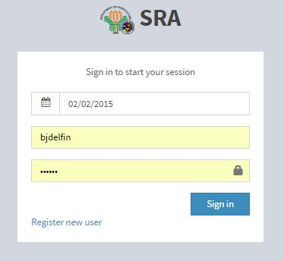

Screen Name : MDO HomeScreen

File Name : Homepage.jsp

Description : The page shows the homepage for the MDO user. The weekly production can be seen here as well as the treemap where the district production can be drilled down to the farmer level. The rainfall forecast can also be seen in this page.

Layout :

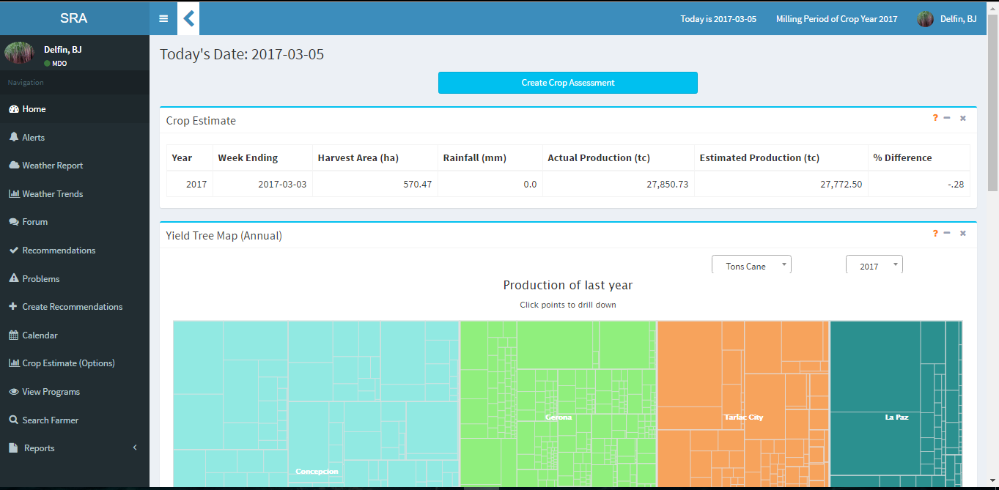

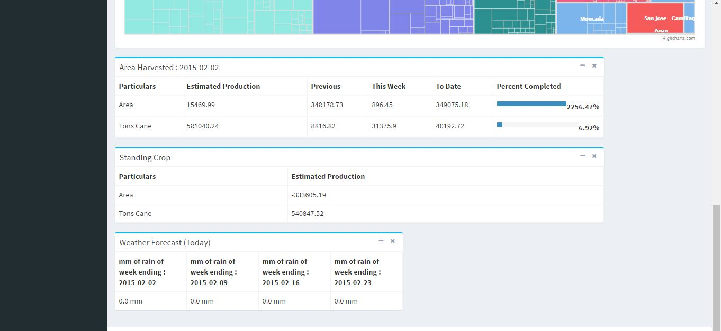

Screen Name : Farmer Profile

File Name : viewFarmerprofile.jsp

Description : The page shows the details of the farmer including his current production and the for the previous years. The list of problems can he has is displayed. The recommendations and programs can also be seen.

Layout :

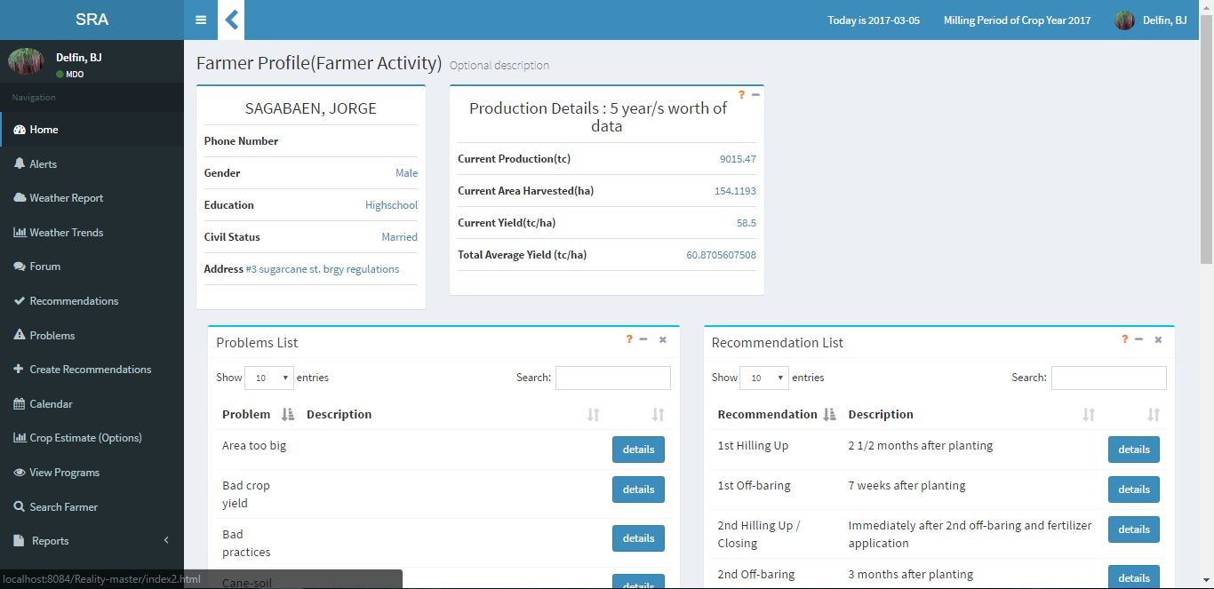

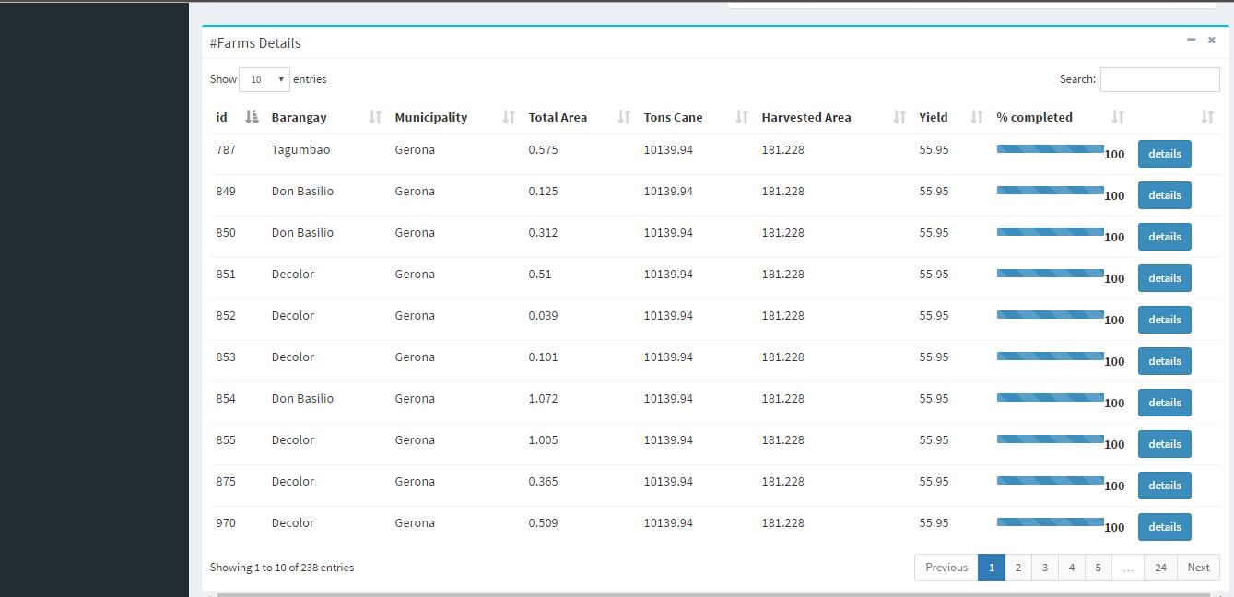

Screen Name : Farmer Profile

File Name : viewFarmerprofile.jsp

Description : The page shows the details of the farm like area and crop characteristics. Here the observation and comparison can be made.

Layout :

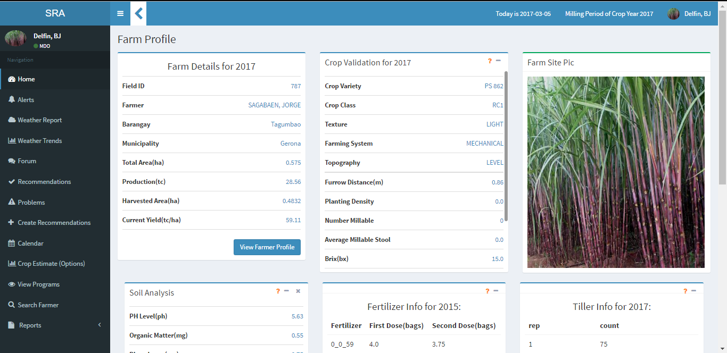

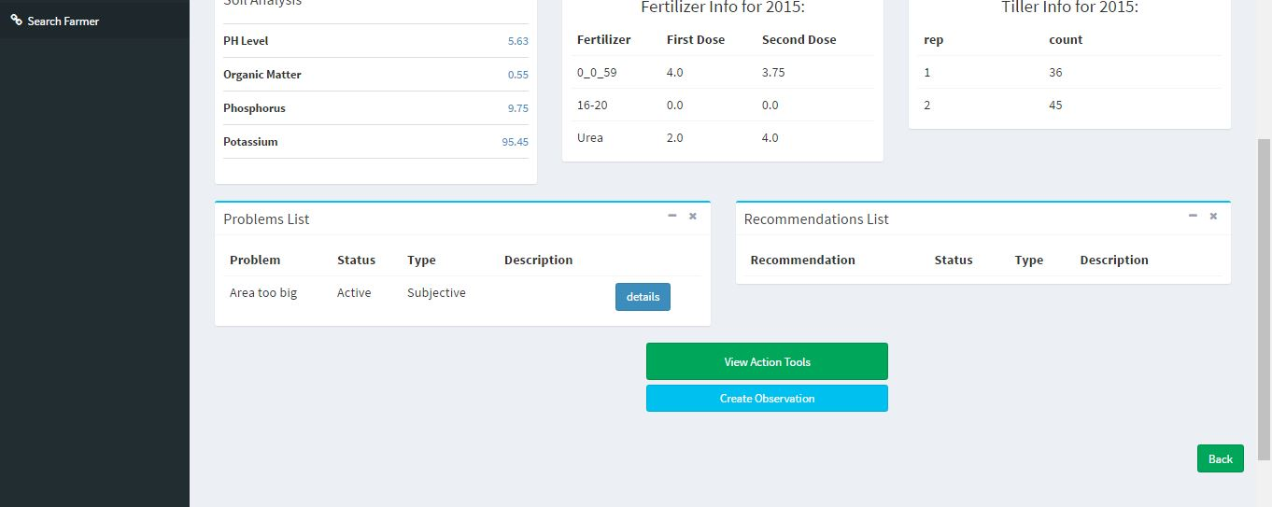

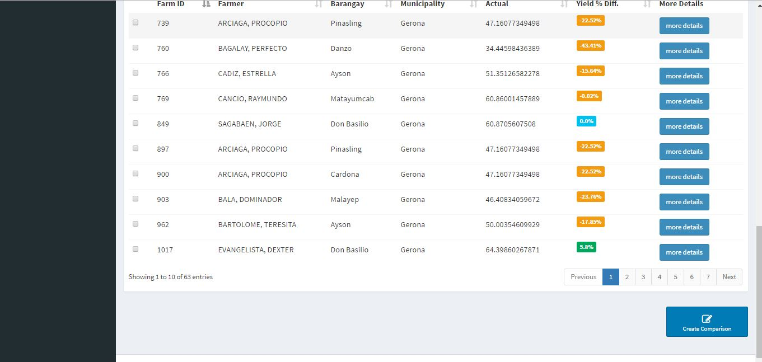

Screen Name : Create Comparison

File Name : viewFarmerdifferences.jsp

Description : The page shows the details of the farm like area and crop characteristics. Here the observation and comparison can be made.

Layout :

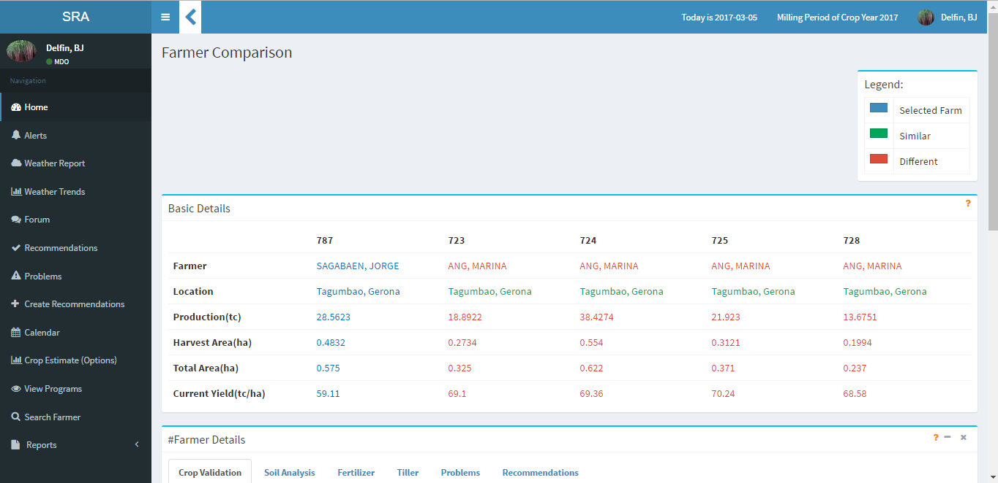

Screen Name : Determine Problem

File Name : viewSendRec.jsp

Description : The page enables the user to determine the problem by selecting the possible problems and putting additional message to be sent to the selected farmer/s.

Layout :

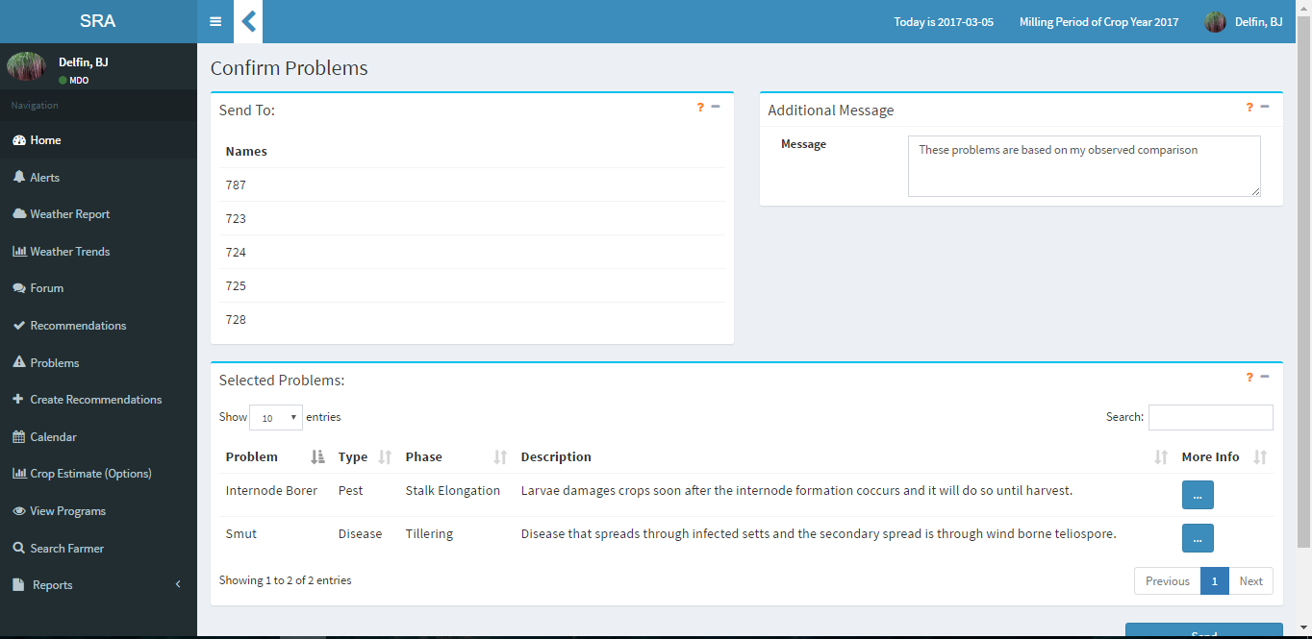

Screen Name : Send other recommendation

File Name : viewSendRec.jsp

Description : The page enables the user to send other recommendations and input additional messages.

Layout :

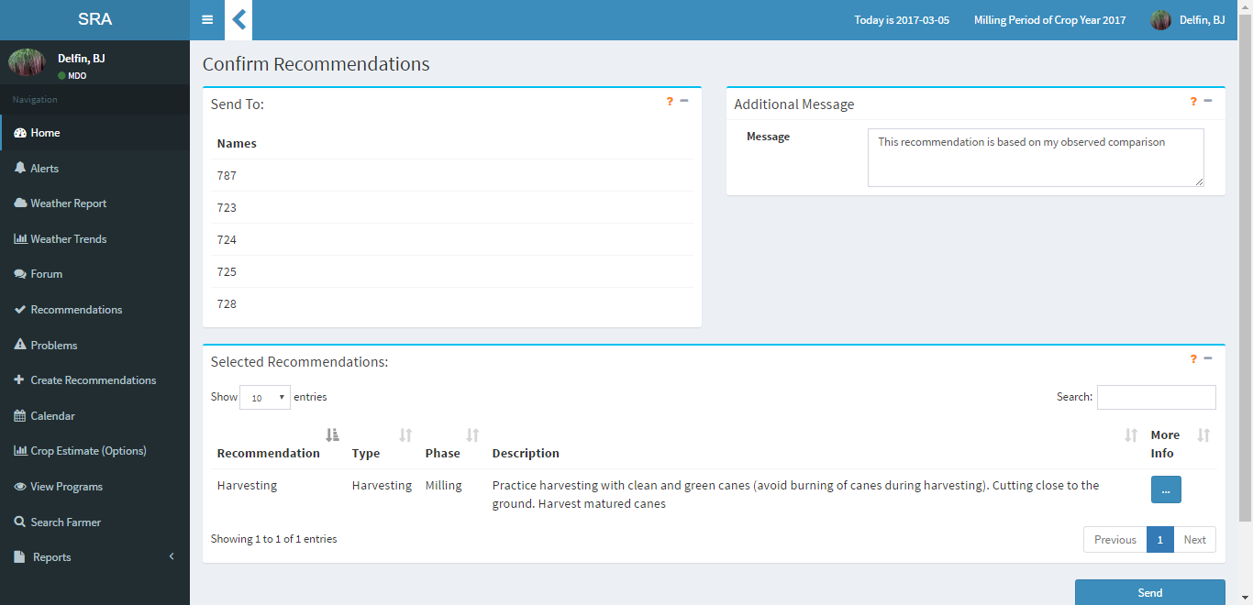

Screen Name : Create Crop Assessment

File Name : viewCropAssessment.jsp

Description : The page allows the user to create a crop assessment report with the production details.

Layout :

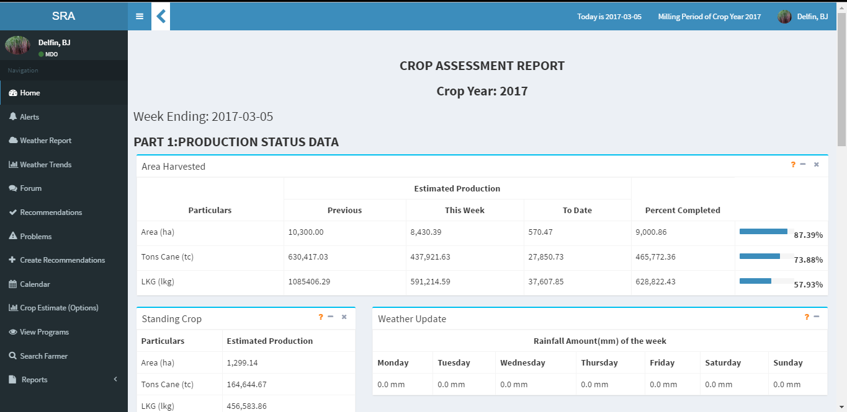

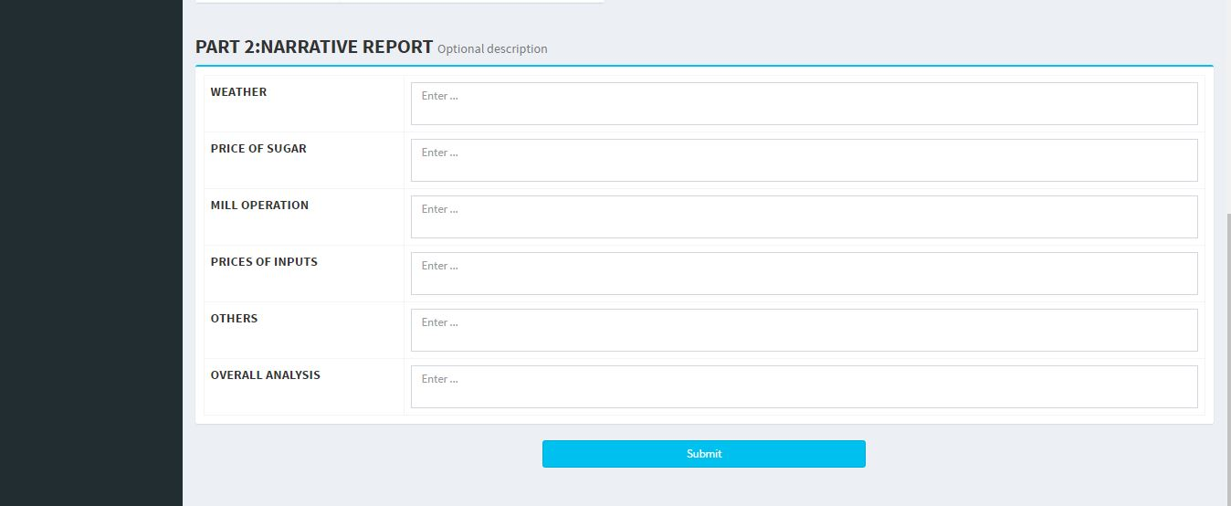

Screen Name : Municipality Summary

File Name : viewMunicipality.jsp

Description : The page shows the production summary of the municipality as well as the barangay.

Layout :

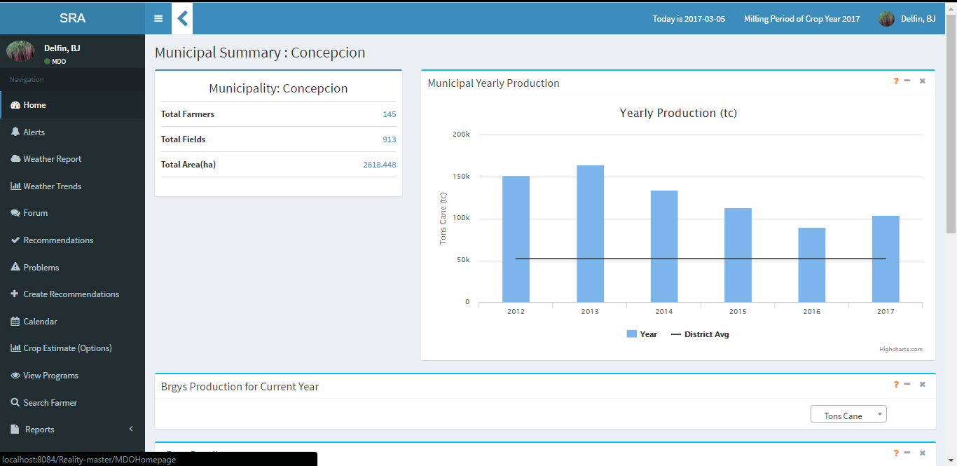

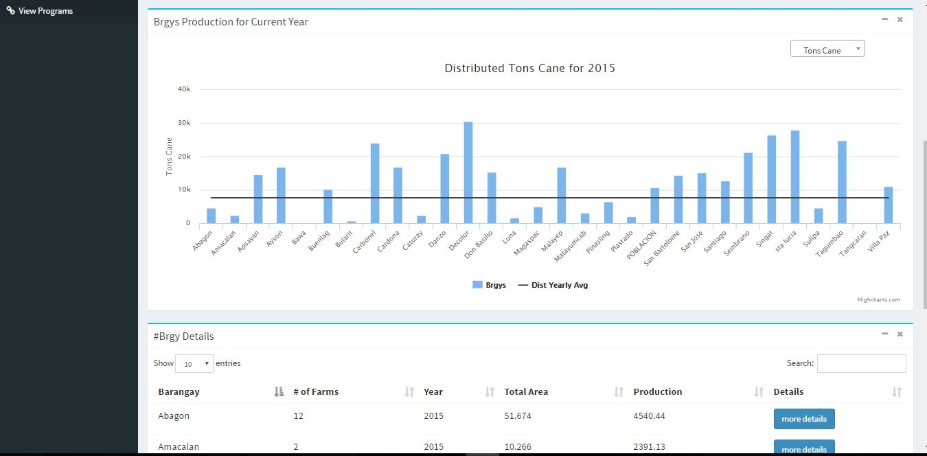

Screen Name : Barangay Summary

File Name : viewbarangay.jsp

Description : The page shows the production summary of the barangay and the farmers inside it.

Layout :

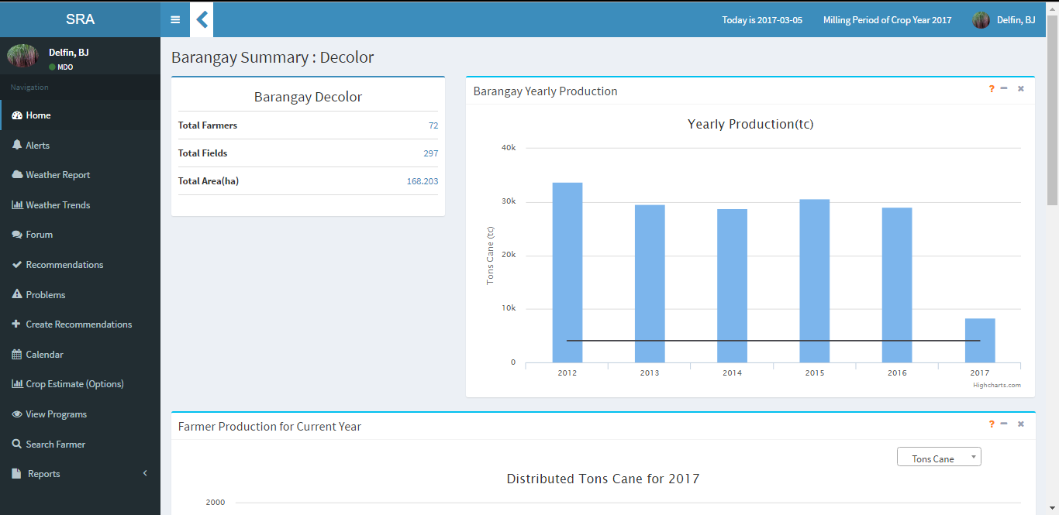

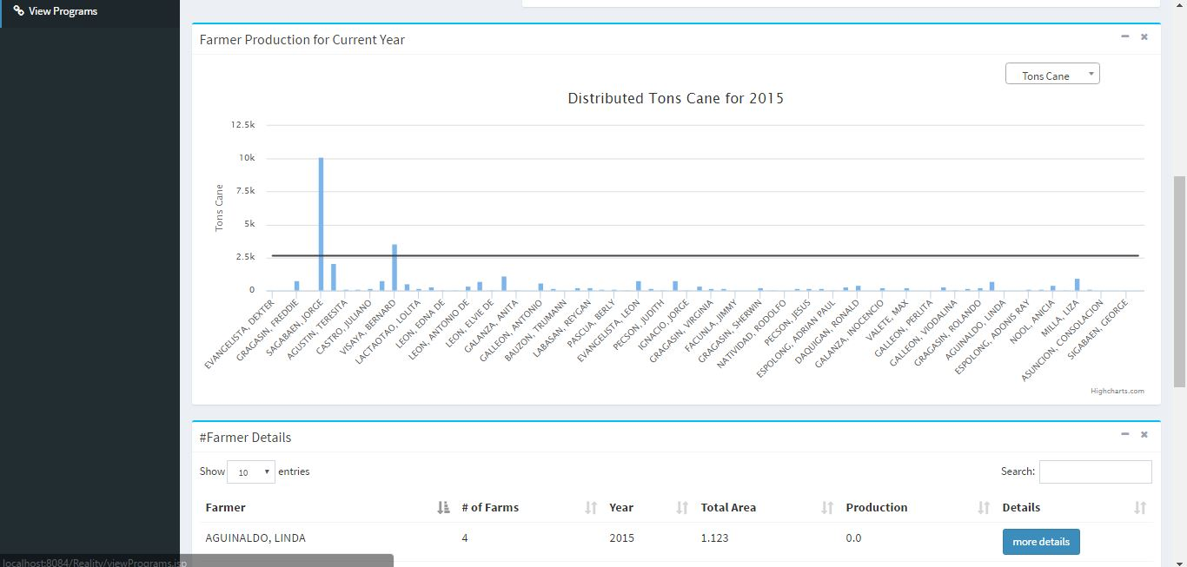

Screen Name : Calendar

File Name : viewPhaseDates.jsp

Description : The page shows the dates and duration of the crop growth phases. The user may edit the phases here and the duration of improvements per phase.

Layout :

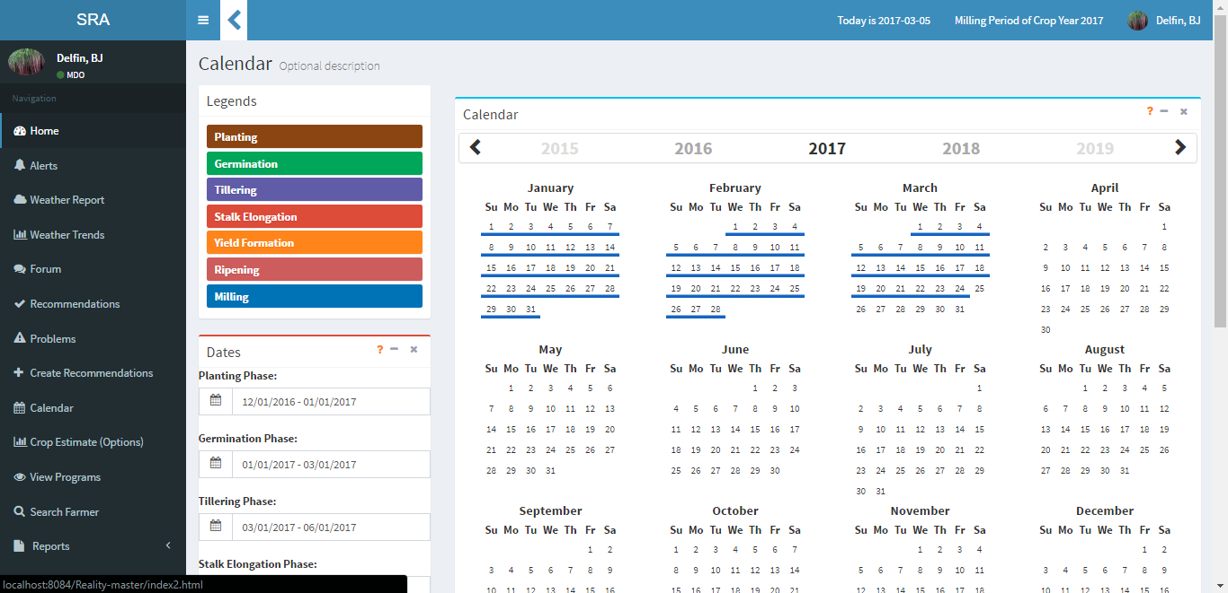

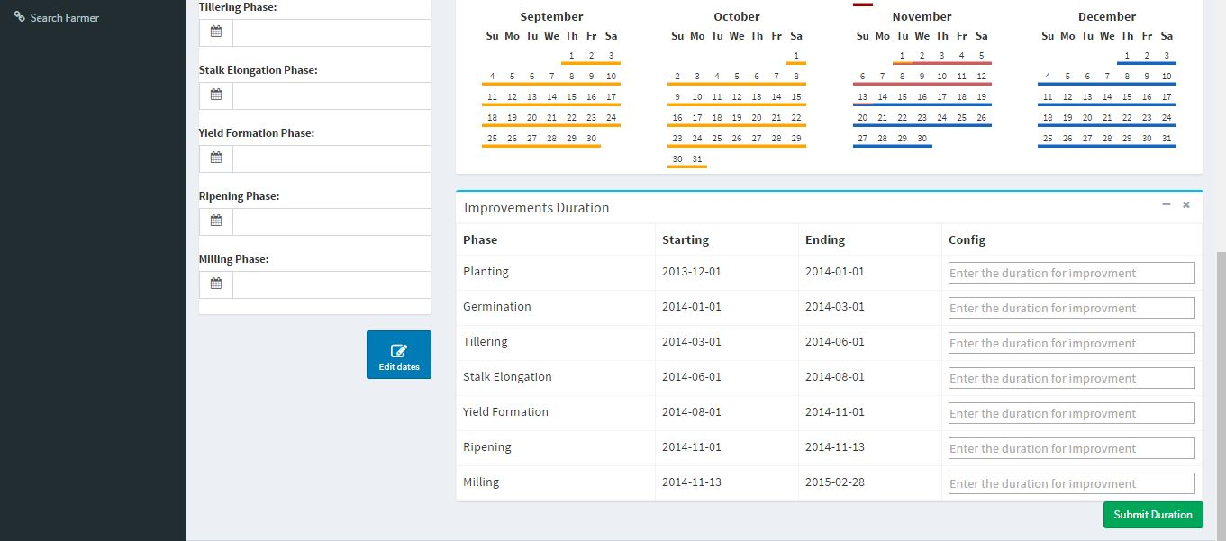

Screen Name : Weather Trends

File Name : viewbarangay.jsp

Description : The page shows the rainfall trend and production per month for 2 years for comparison. Here the weather related recommendation can be modified

Layout :

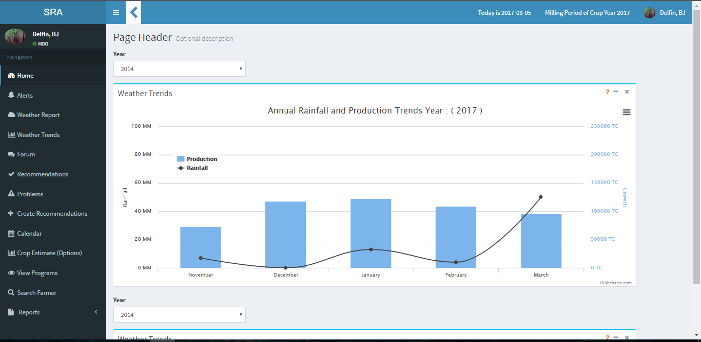

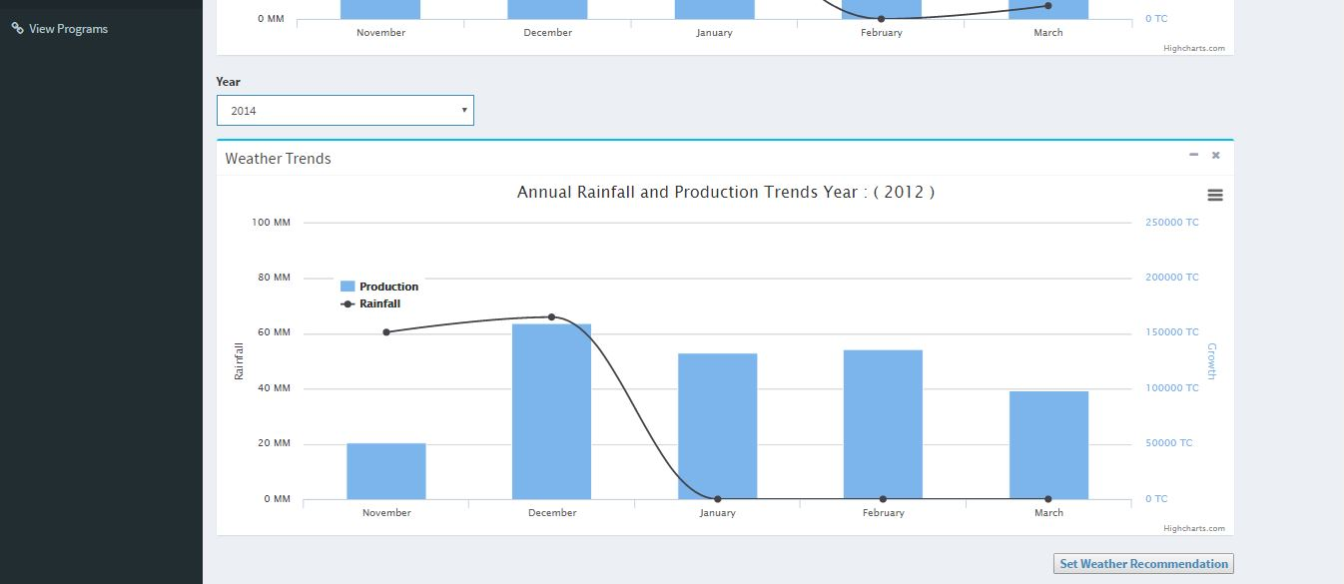

Screen Name : View Recommendations List

File Name : Recommendations.jsp

Description : The page shows the list of recommendations. The button can be clicked to see the details.

Layout :

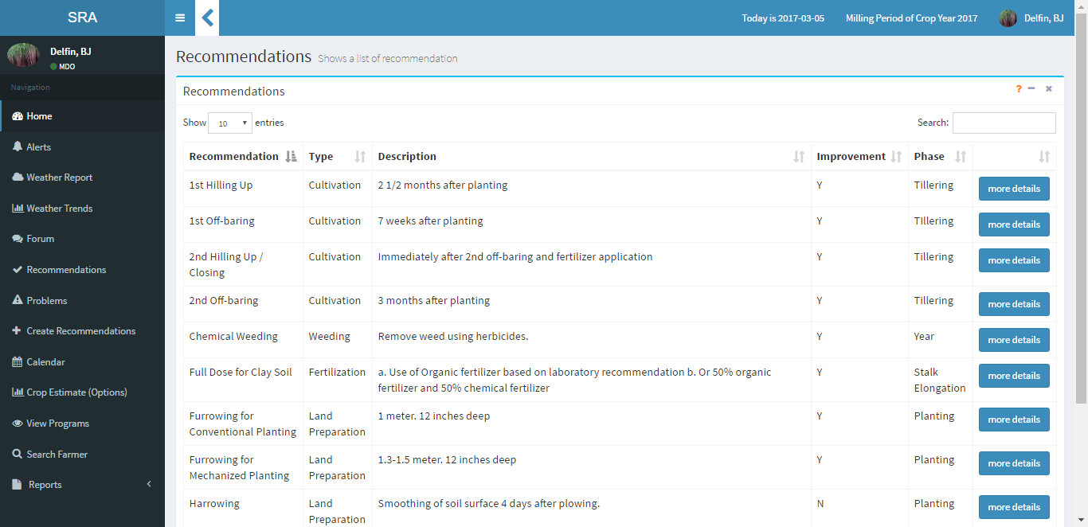

Screen Name : Recommendation Details

File Name : viewRecdetails.jsp

Description : The page shows the details of the recommendations and the farms that have the recommendation

Layout :

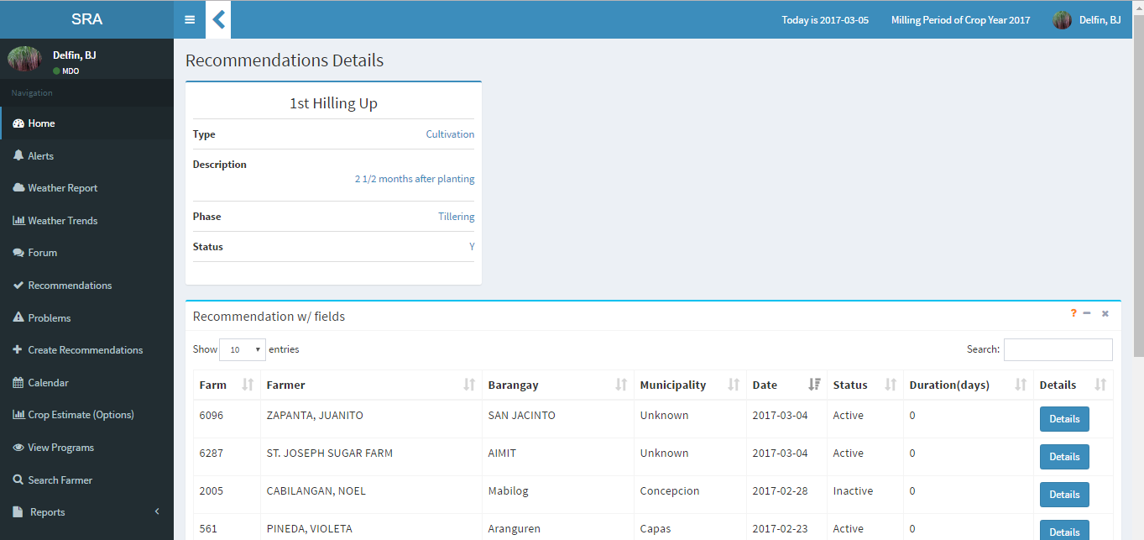

Screen Name : Problem List

File Name : Problems.jsp

Description : The page shows the list of problems.

Layout :

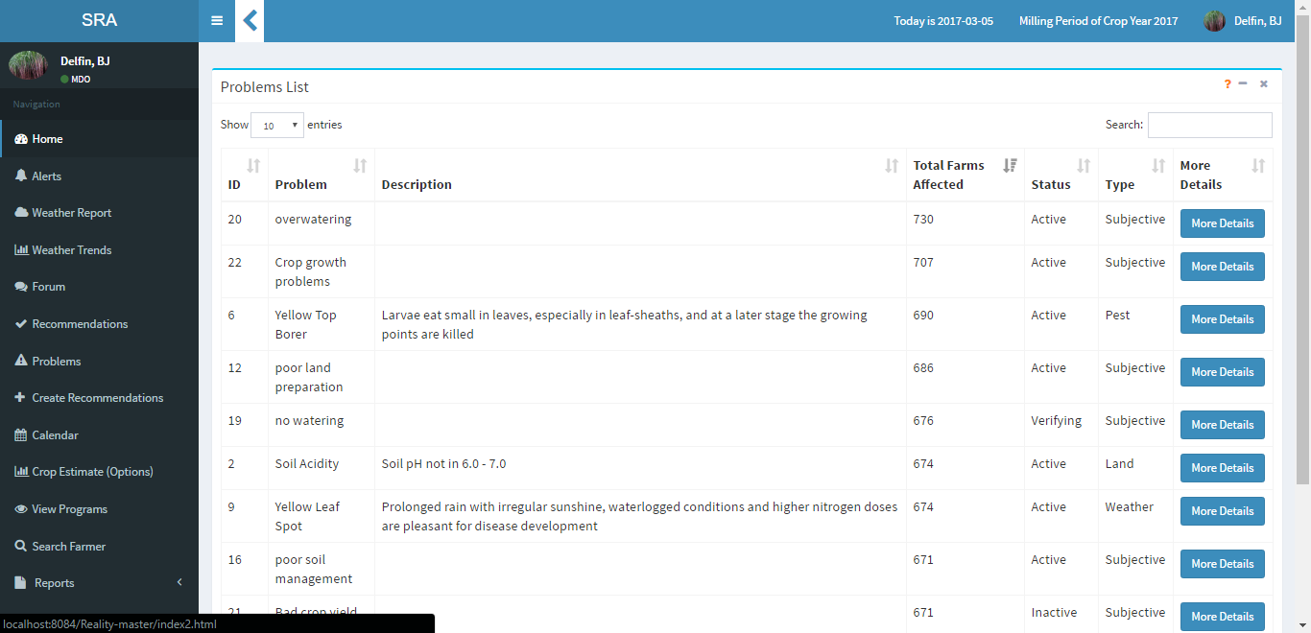

Screen Name : Problem Details

File Name : viewprobdetails.jsp

Description : The page shows the production summary of the barangay and the farmers inside it. The user is able to create a recommendation or a program

Layout :

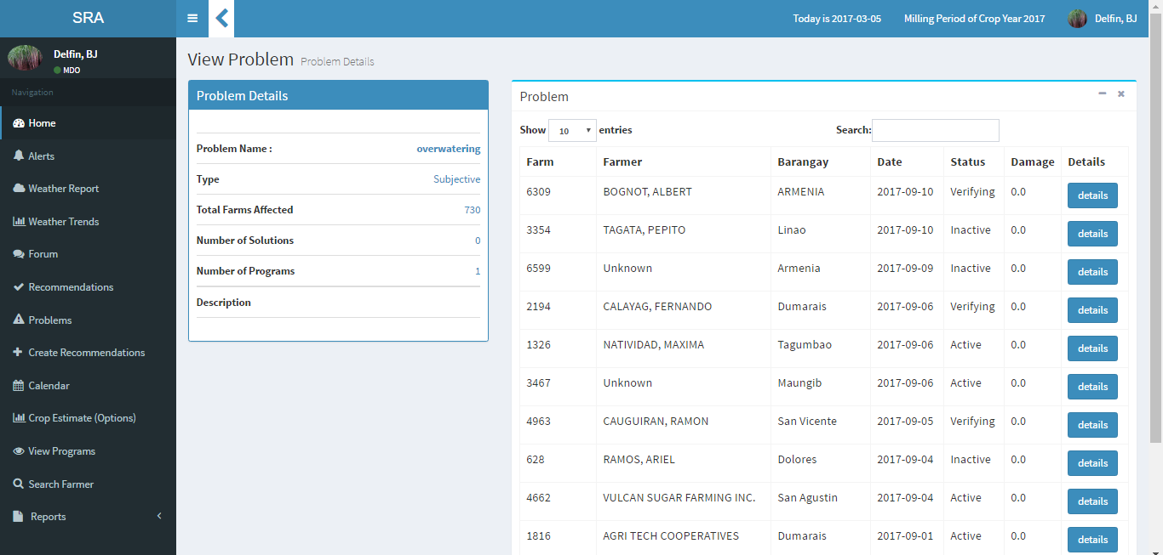

Screen Name : Program Lists

File Name : viewPrograms.jsp

Description : The page shows the list of programs

Layout :

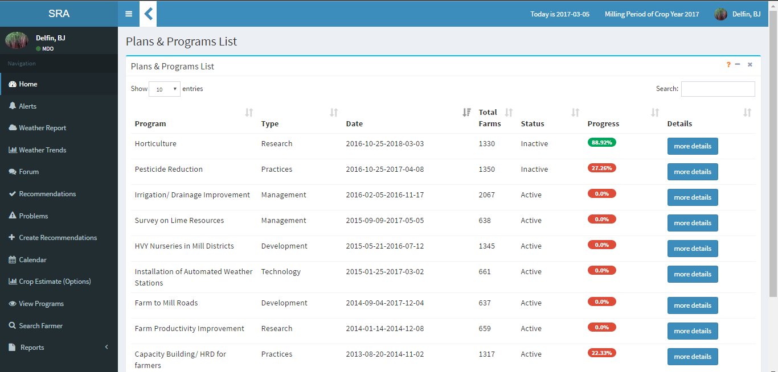

Screen Name : Program Details

File Name : viewbarangay.jsp

Description : The page shows the production summary of the barangay and the farmers inside it.

Layout :

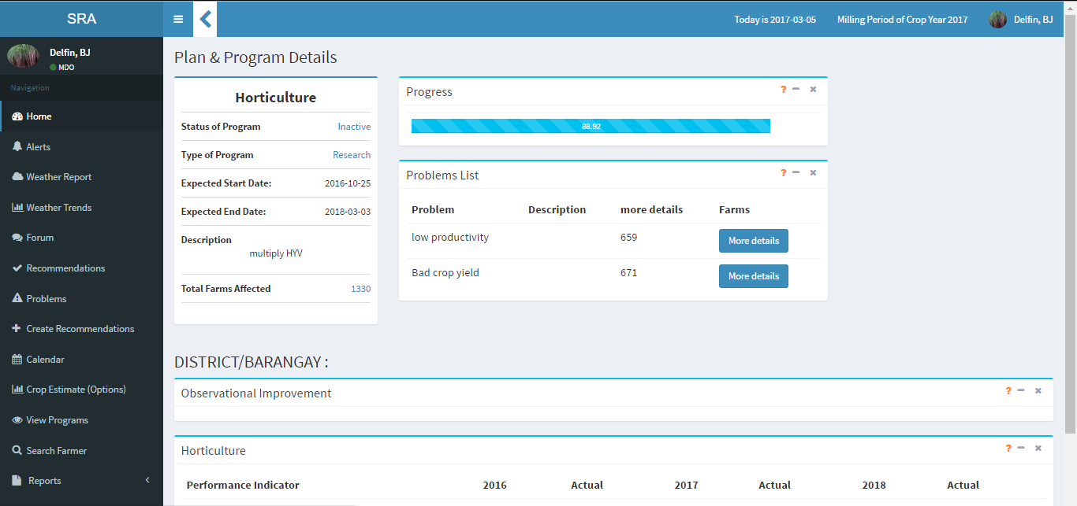

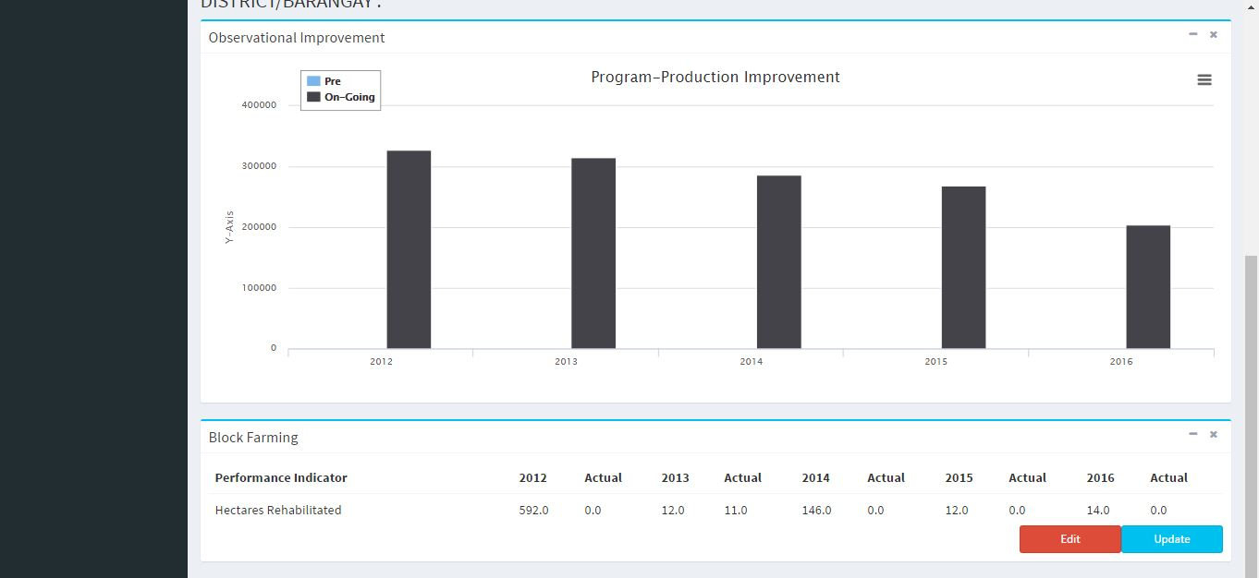

Screen Name : Create Program

File Name : createprogram.jsp

Description : The page allows the user to select problems, input the program details and set the performance indicators.

Layout :

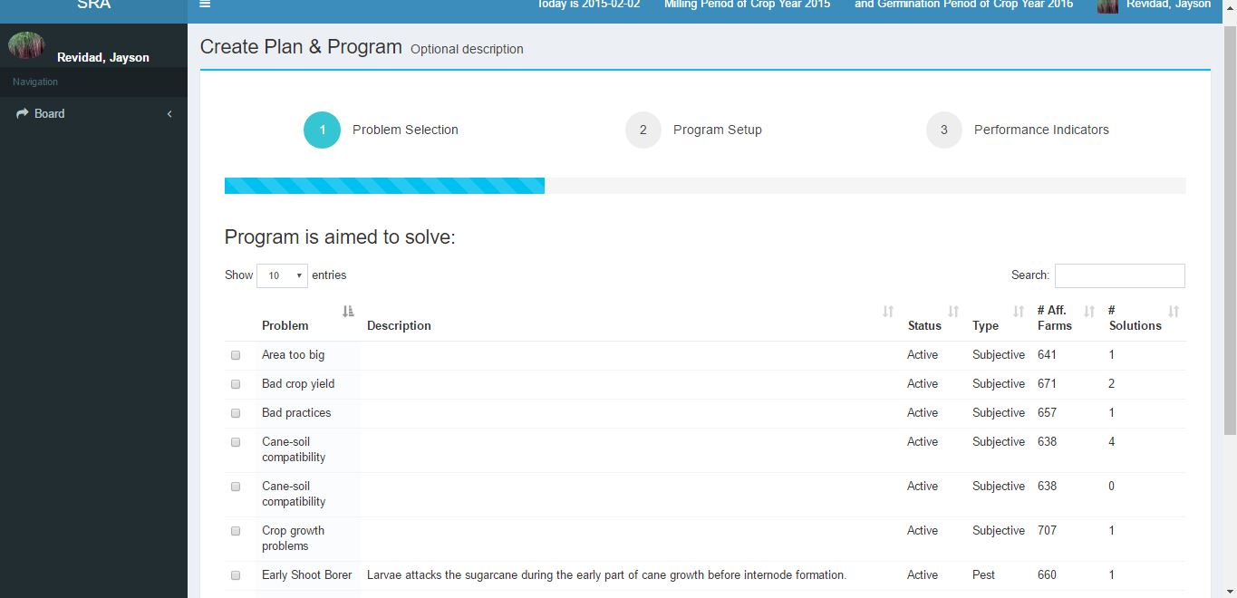

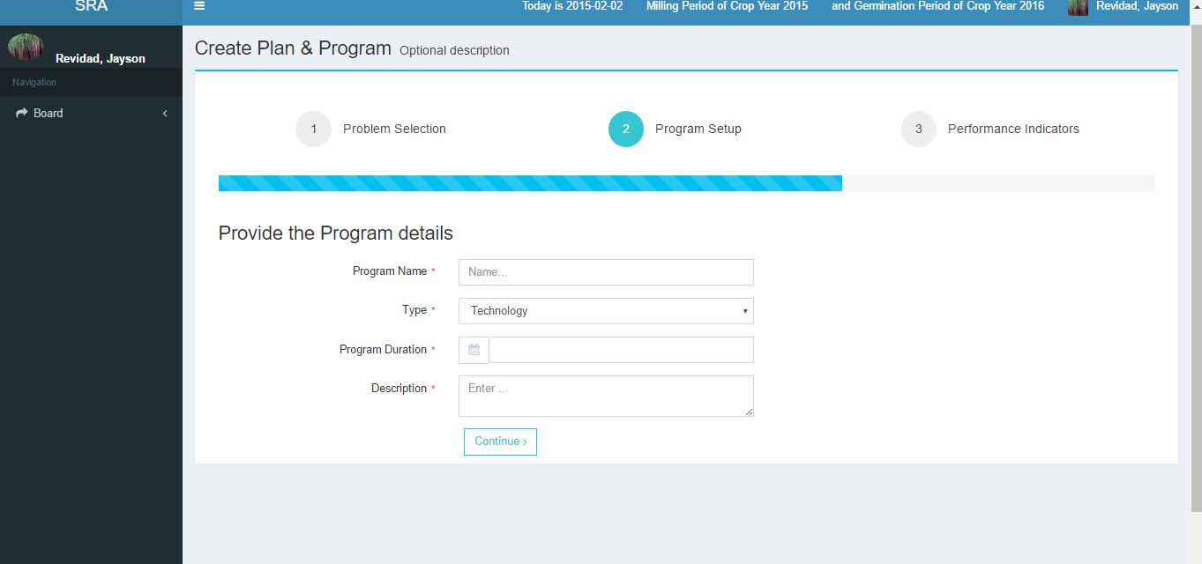

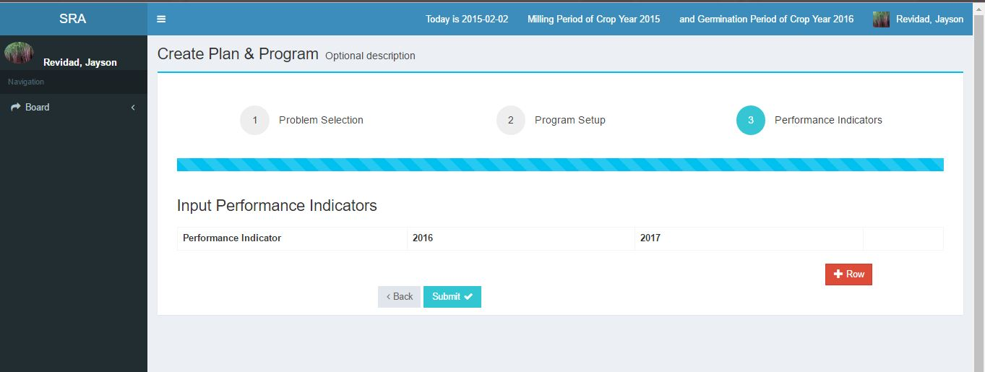

Screen Name : Forum

File Name : Forum.jsp

Description : The page shows the list of posts with their statuses.

Layout :

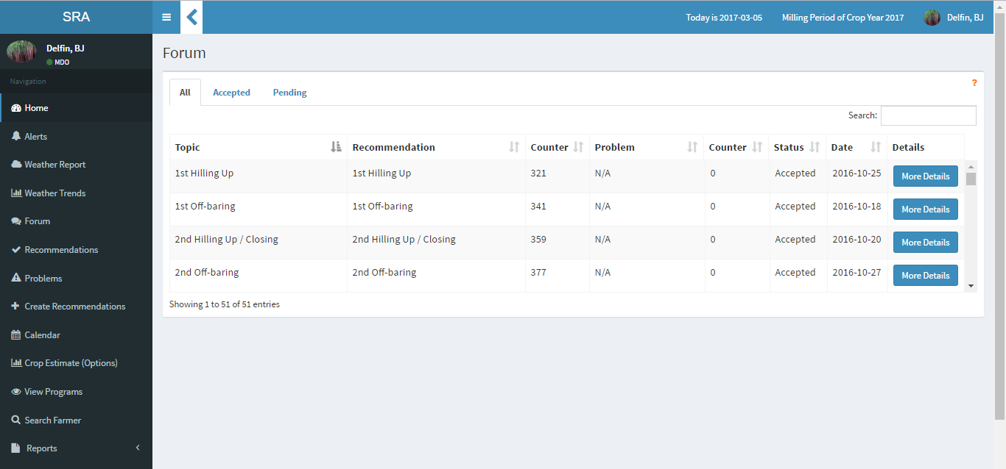

Screen Name : Forum Post

File Name : ApprovePost.jsp

Description : The page shows the post of the farmer made in the forum and the MDO can approve or reject the post.

Layout :

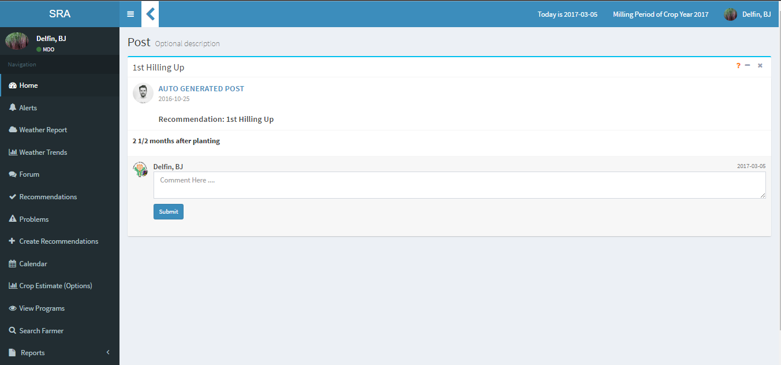

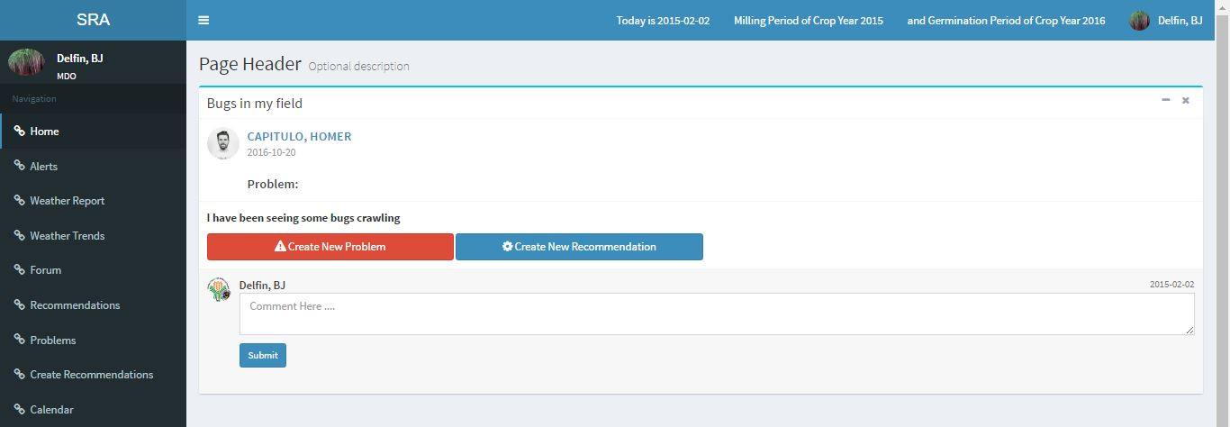

Screen Name : Create New Problem

File Name : ApprovePost.jsp

Description : The page allows the user to create a problem based on his evaluation of the post.

Layout :

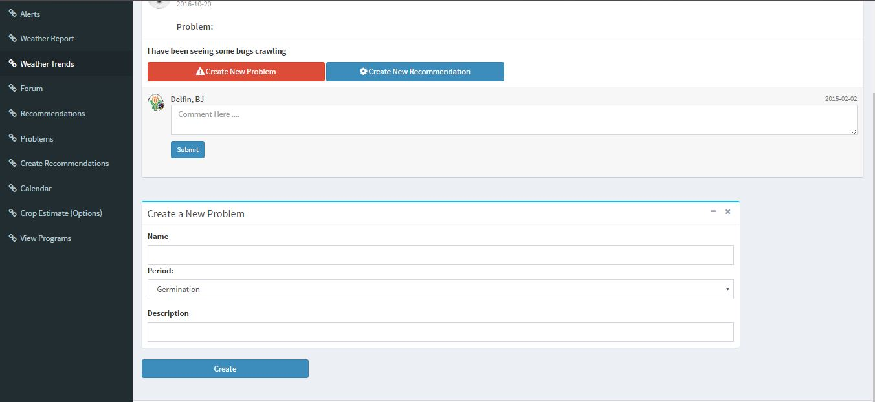

Screen Name : Create Recommendation Forum

File Name : ApprovePost.jsp

Description : The page allows the user to create a recommendation.

Layout :

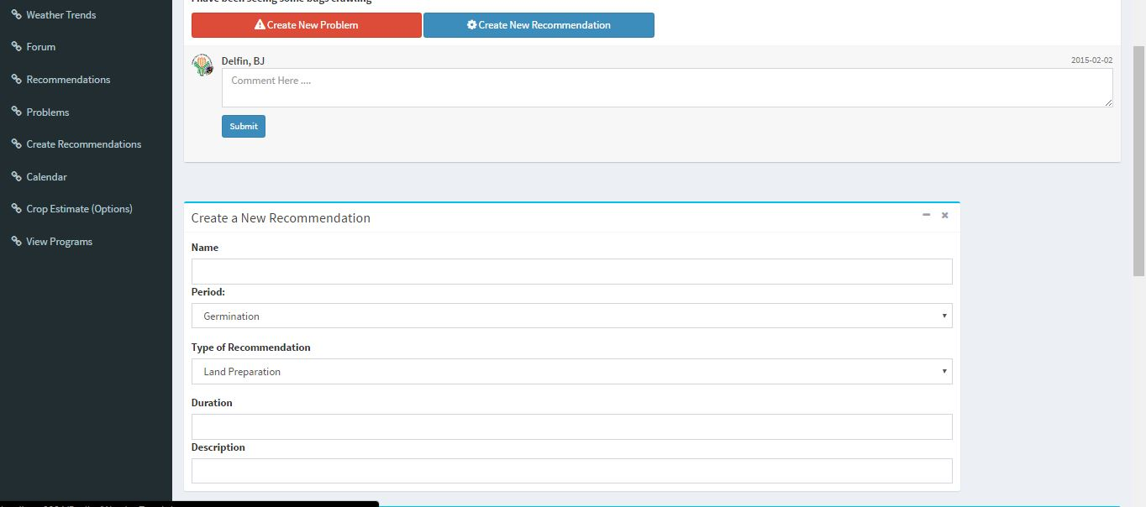

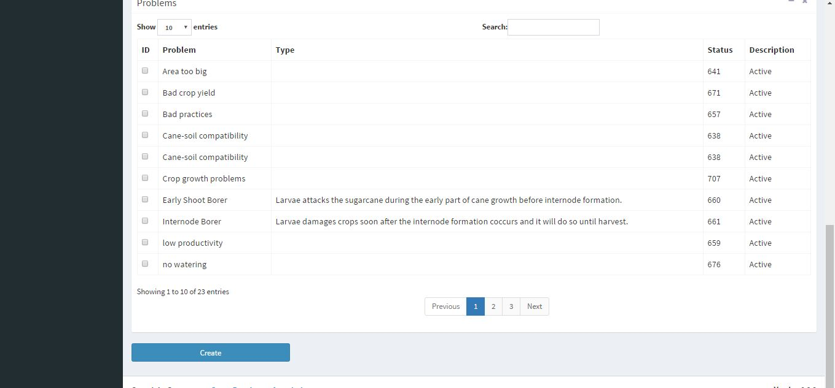

Screen Name : Disaster Report

File Name : Disaster.jsp

Description : The page shows the list of disasters reported.

Layout :

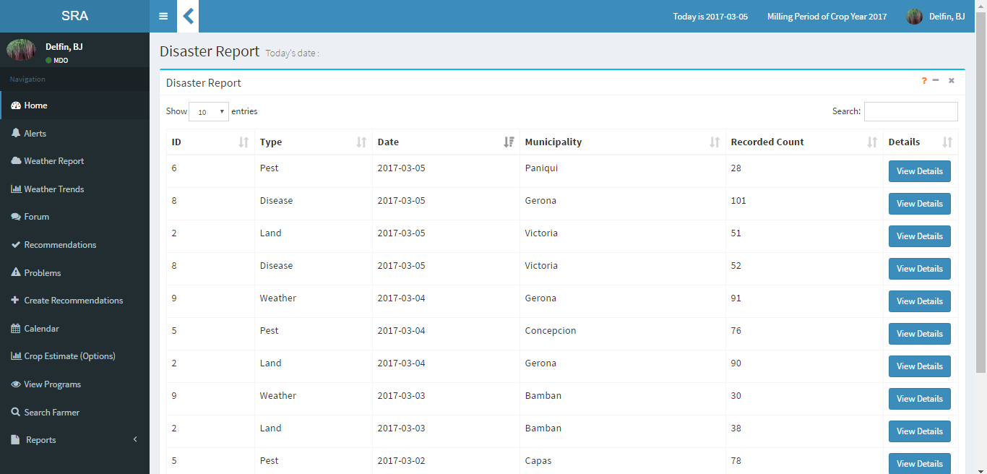

Screen Name : Send Alert

File Name : alert.jsp

Description : The page allows the user to send alerts with messages to the farmer.

Layout :

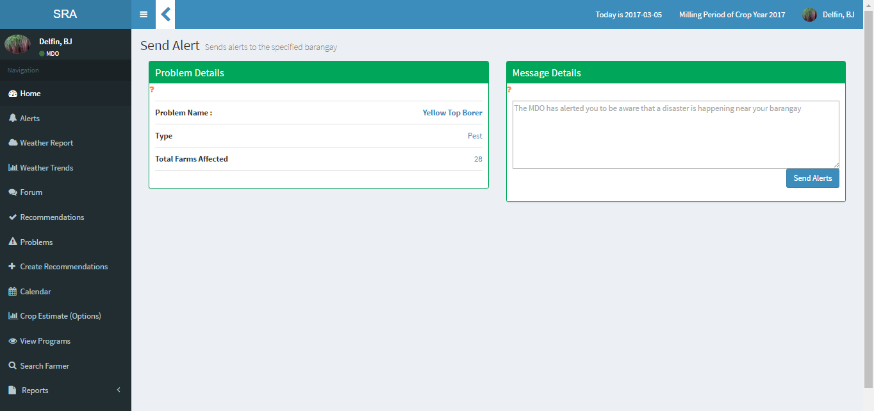

Screen Name : Create Recommendation

File Name : createNewRecommendation.jsp

Description : The page allows the user to create a new recommendation and choose between two types: solving a problem or for improvement

Layout :

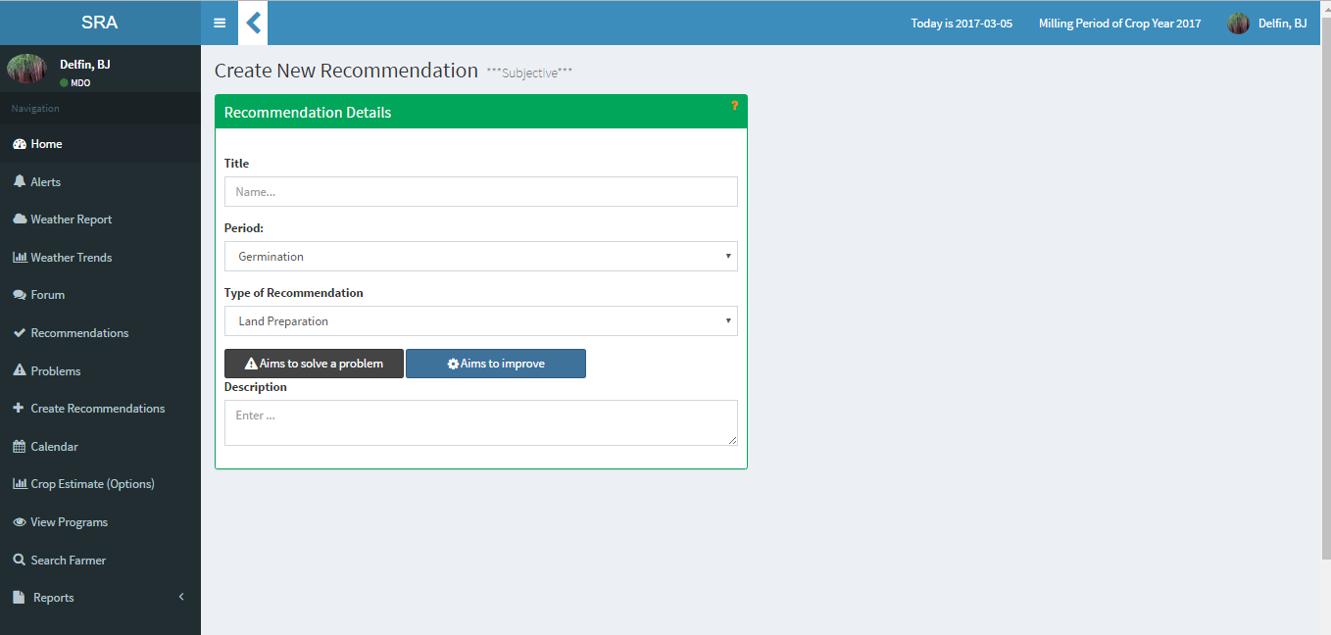

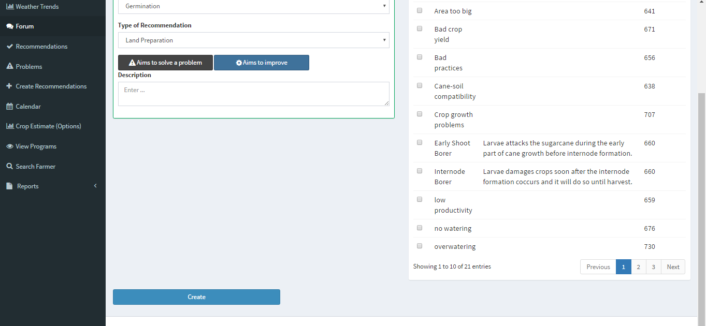

Screen Name : View Recommednation list

File Name : Recommendation.jsp

Description : The page allows the user to see the list of recommendations

Layout:

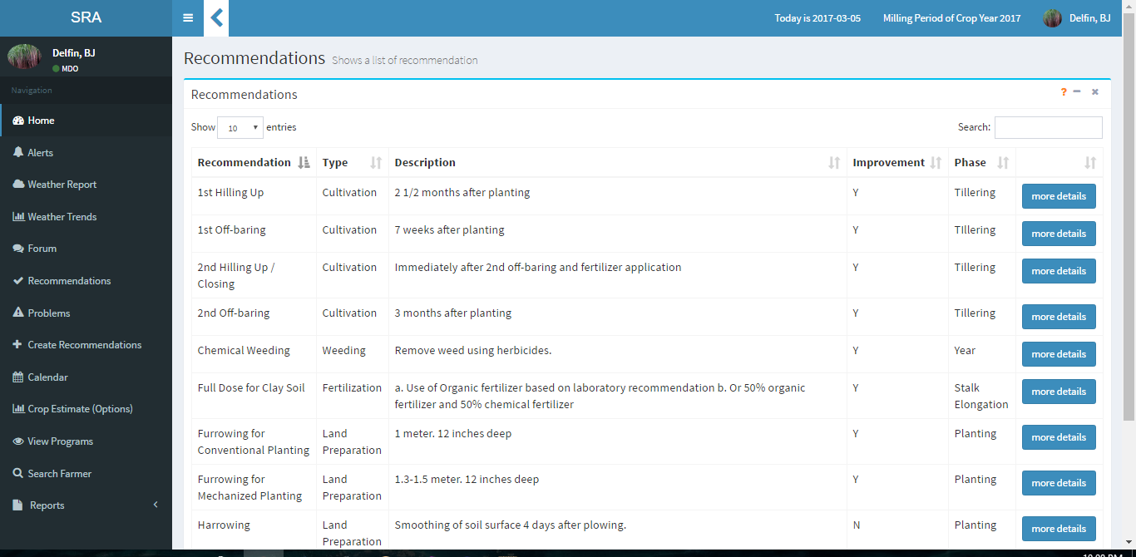

Screen Name : View Recommednation Details

File Name : Recommendation.jsp

Description : The page allows the user to see the details of the recommendation

Layout:

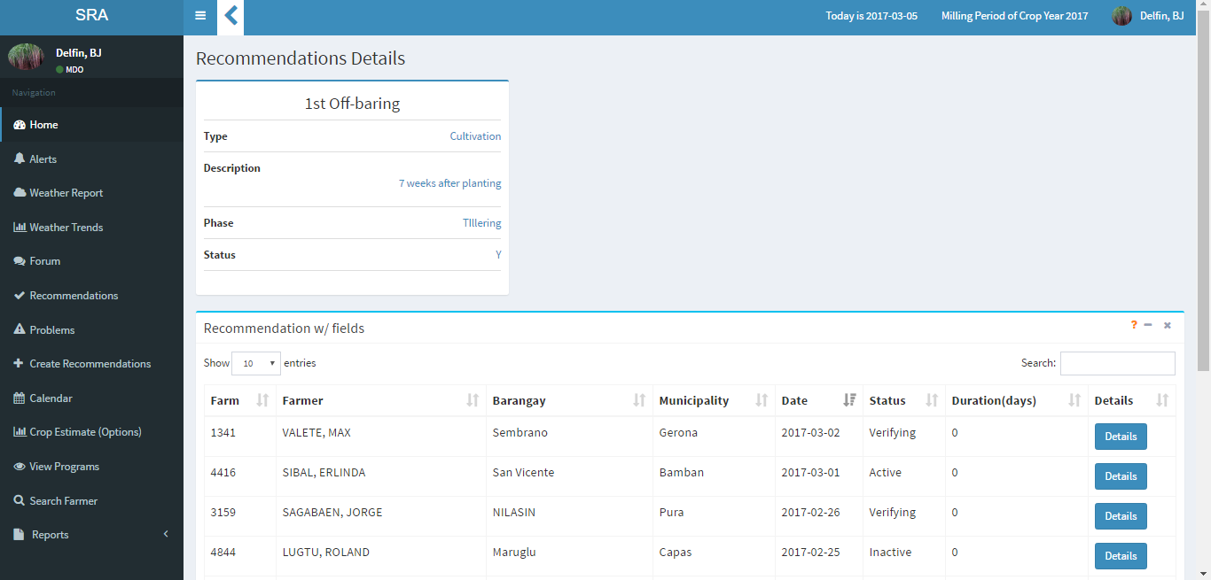

Screen Name : Dashboard

File Name : boardhome.jsp

Description : The page shows the user the national weekly production and the list of ongoing programs

Layout :

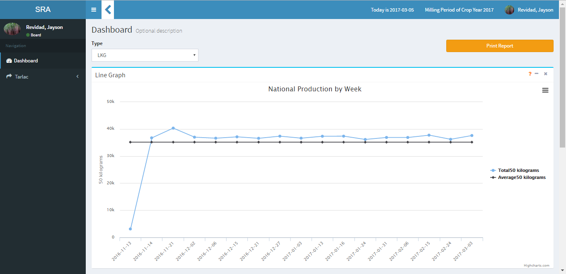

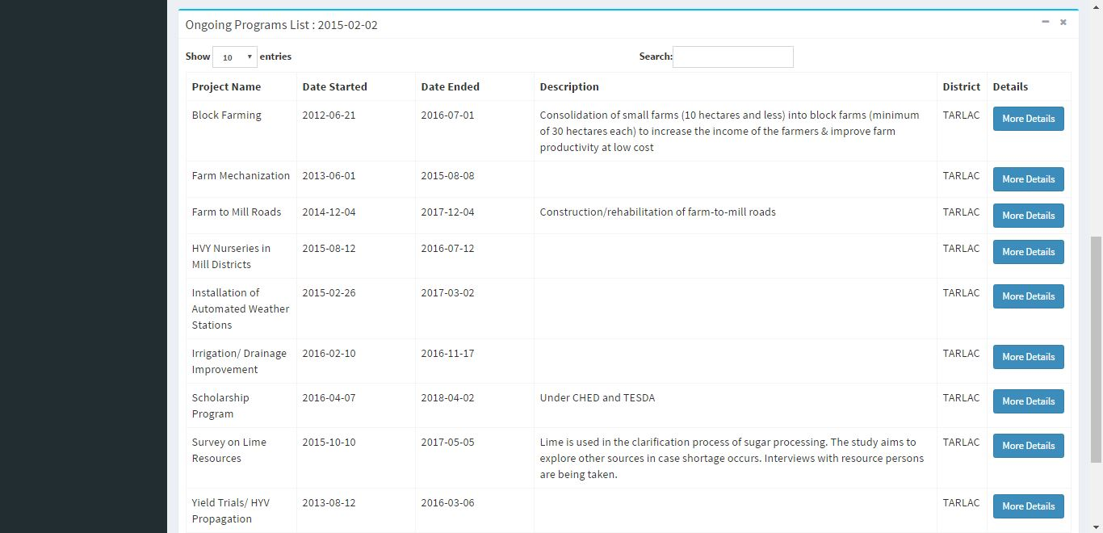

Screen Name : Weekly Produced

File Name : viewWeeklyProductionReport.jsp

Description : The page allows the user to drill down the dashboard and view the production of each region

Layout :

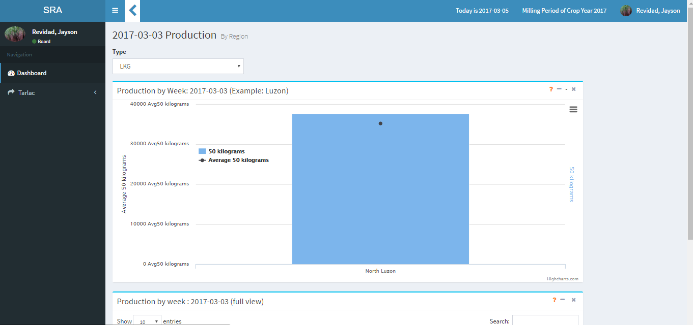

Screen Name : Weeky Statistics

File Name : Productiondetails.jsp

Description : The page shows the details of the selected region.

Layout :

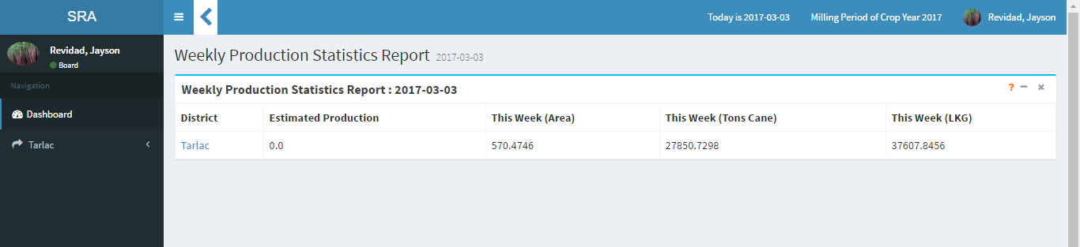

Screen Name : Search Farmer

File Name : SearchFarmer.jsp

Description : The page allows the user to see the list of farmers

Layout:

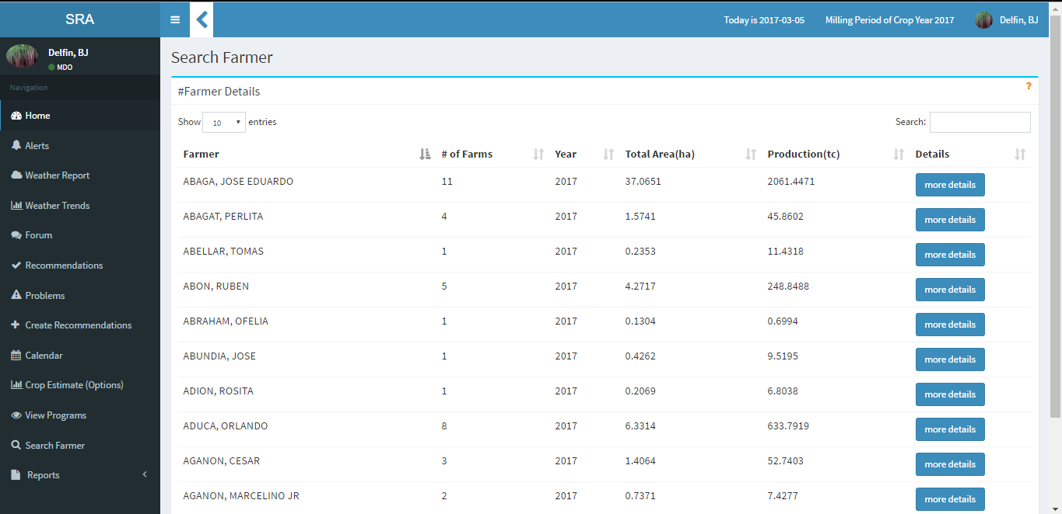

Screen Name : Crop Estimate

File Name : CropEstimate.jsp

Description : The page allows the user to generate forecasts and compare them

Layout:

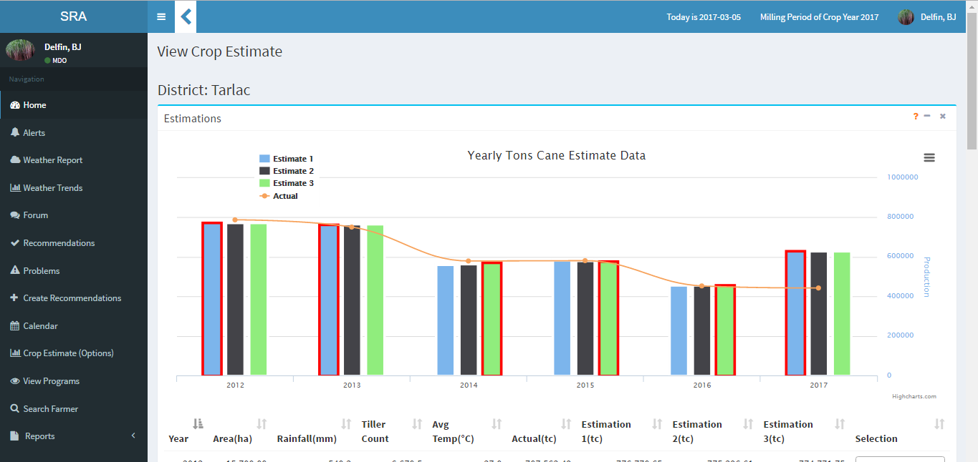

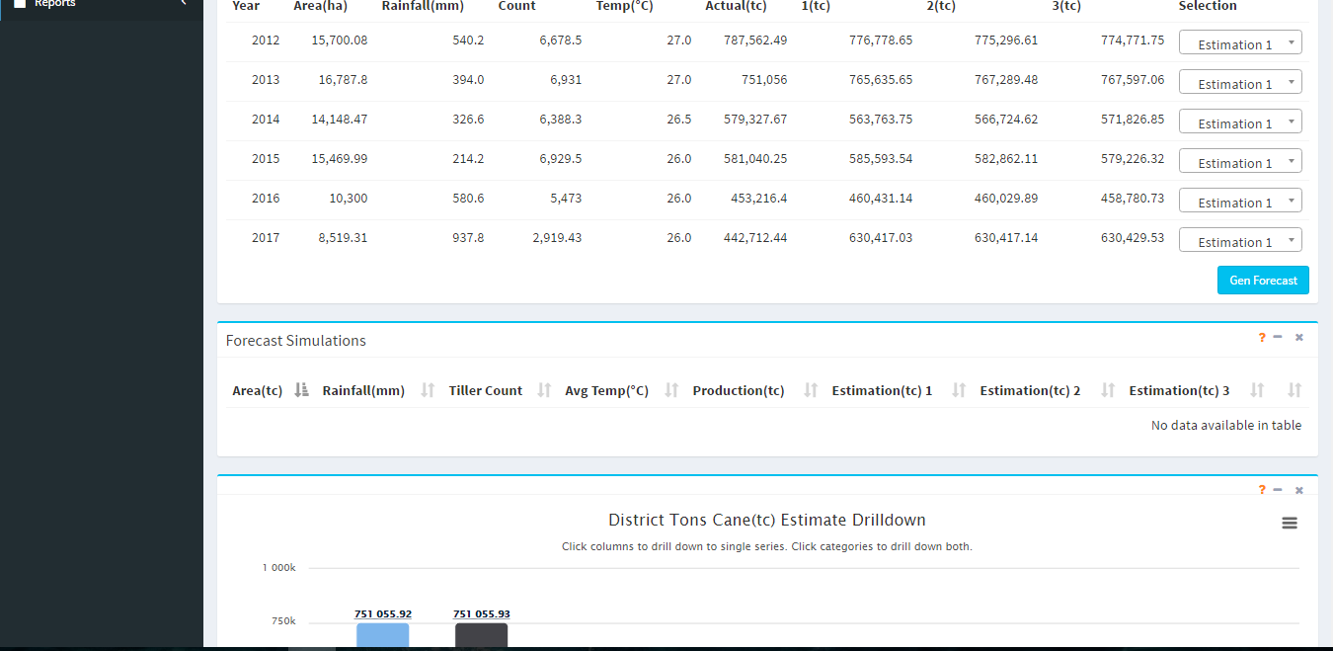

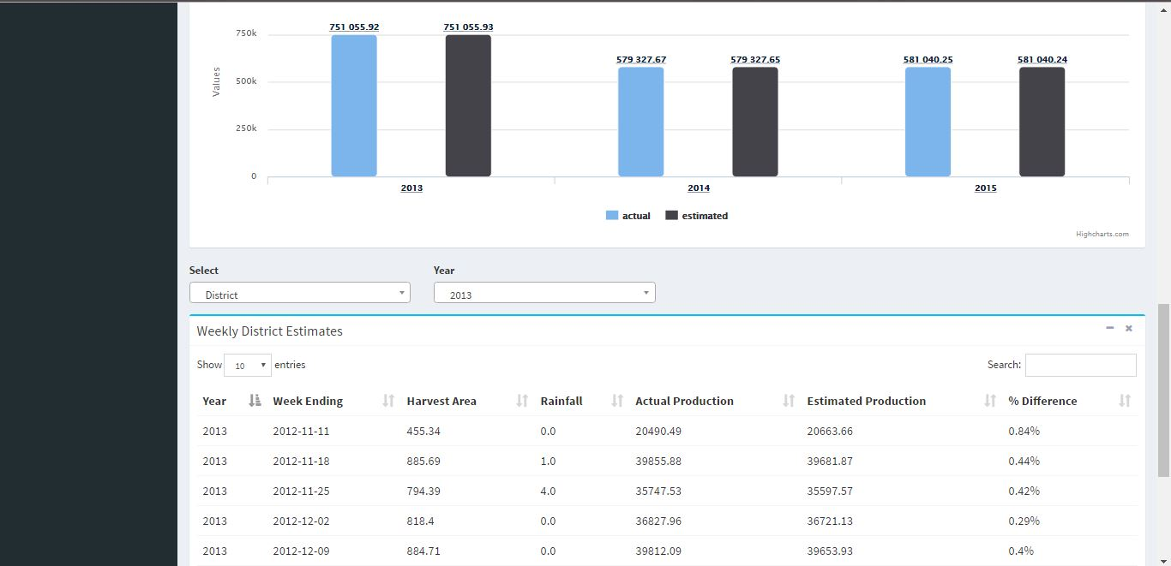

Screen Name : Farmer Login

Description : The page shows the login for the farmer’s mobile application

Layout :

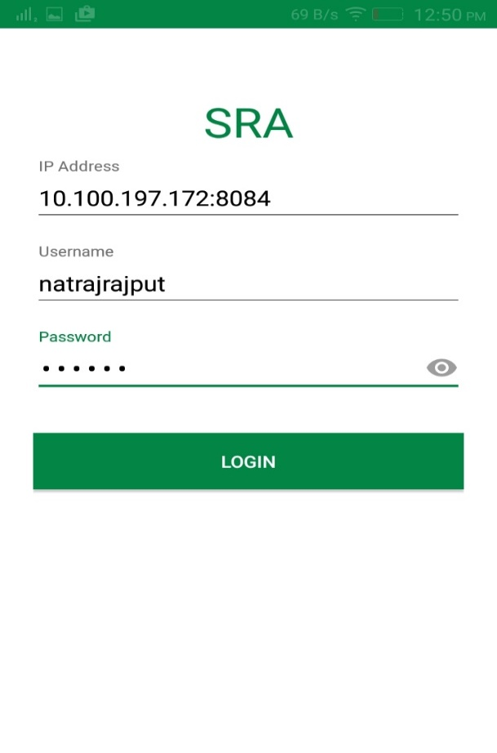

Screen Name : Farmer Main Menu

Description : The page shows the main menu for farmer’s mobile application

Layout :

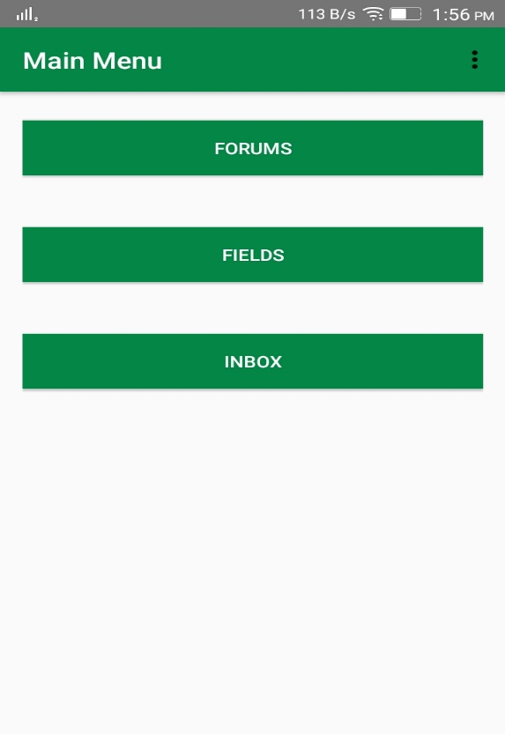

Screen Name : Farm Survey Menu

Description : The page shows the menu for the different parts of the Crop Validation Survey

Layout :

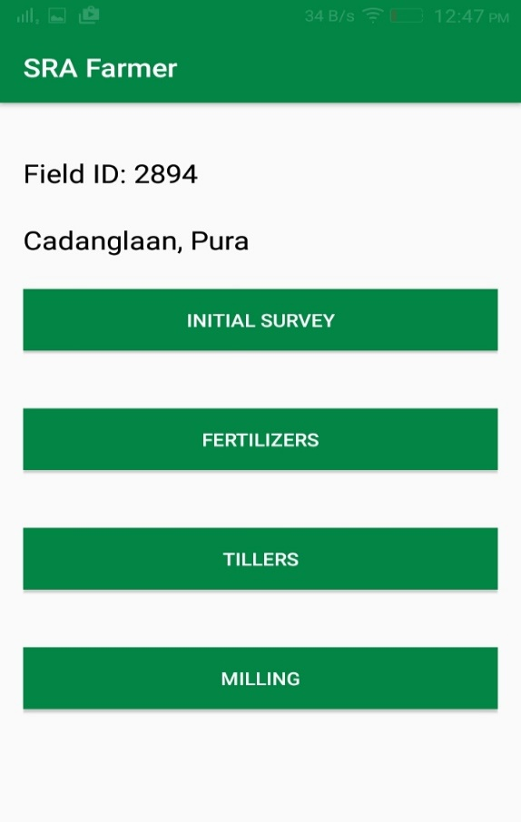

Screen Name : Input Production

Description : The page allows the user to input his area harvested and production

Layout :

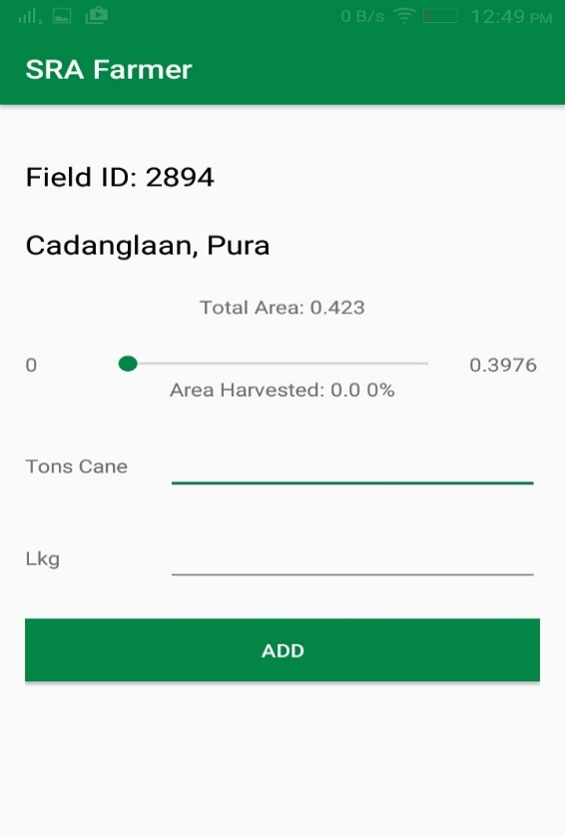

Screen Name : Farmer Forum

Description : The page allows the farmer to view and search posts

Layout :

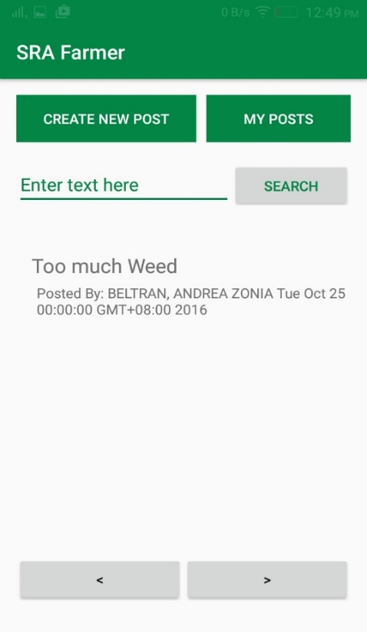

Screen Name : Create Farmer

Description : The page allows the mdo to create/register a farmer and plot his area.

Layout :

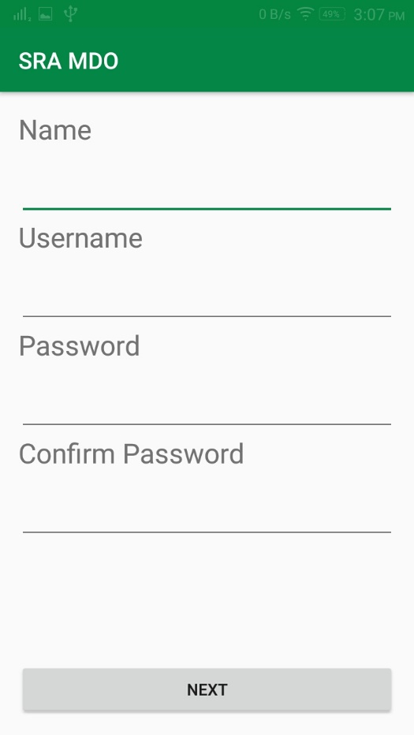

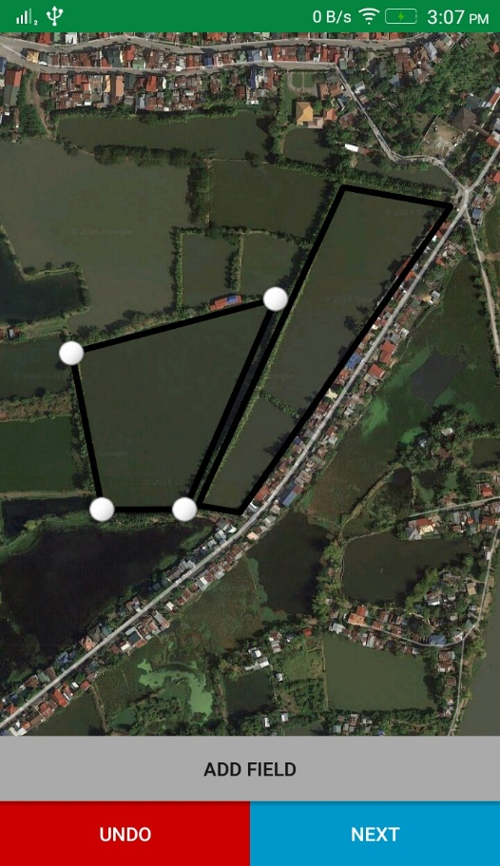

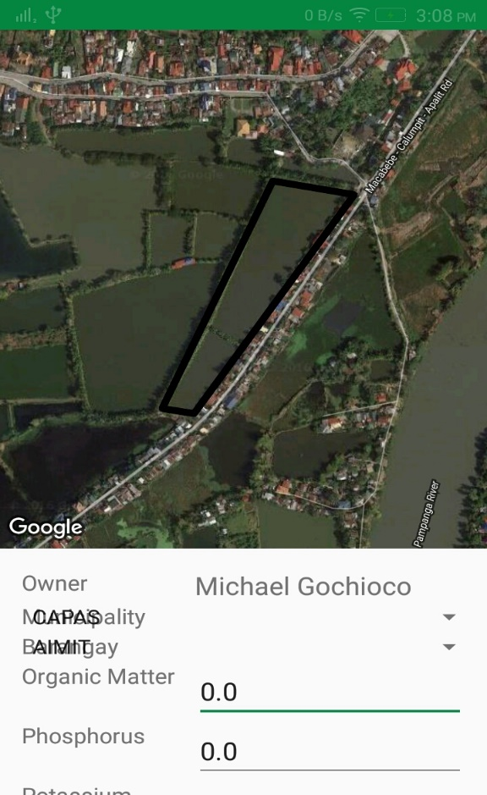

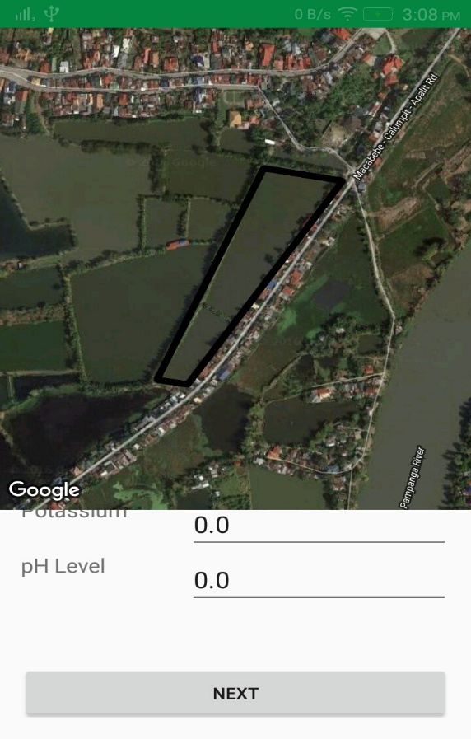

Screen Name : Inbox

Description : The page shows the farmer’s notifications for new recommendations, problems and updates to forum posts.

Layout :

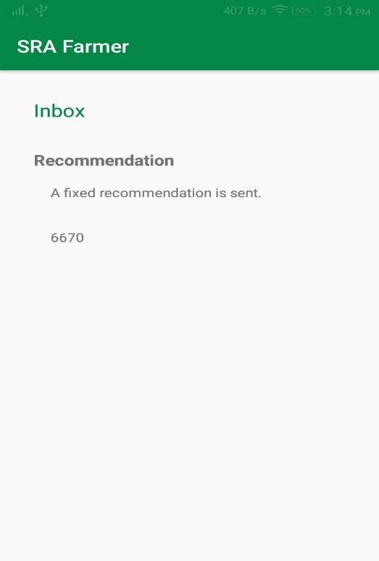

Screen Name : Crop Validation Survey for MDO

Description : The page allows the MDO to fill up the farmer’s Crop Validation Survey.

Layout :

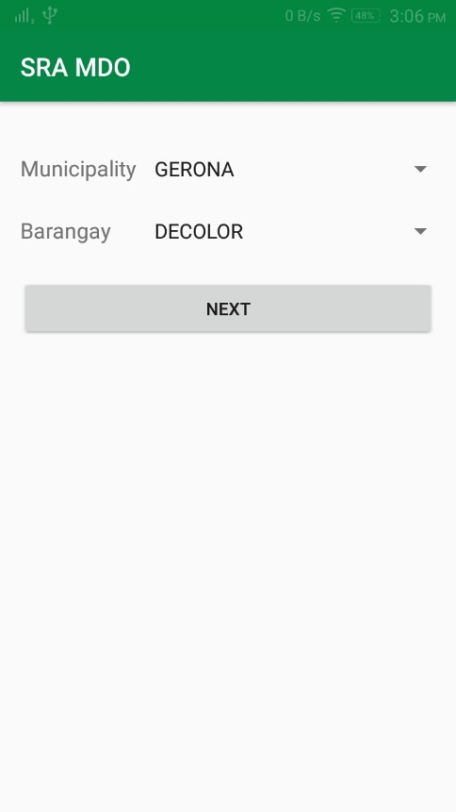

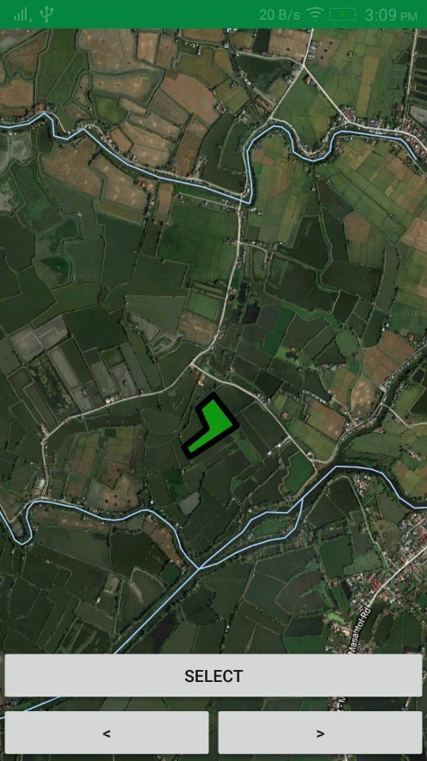

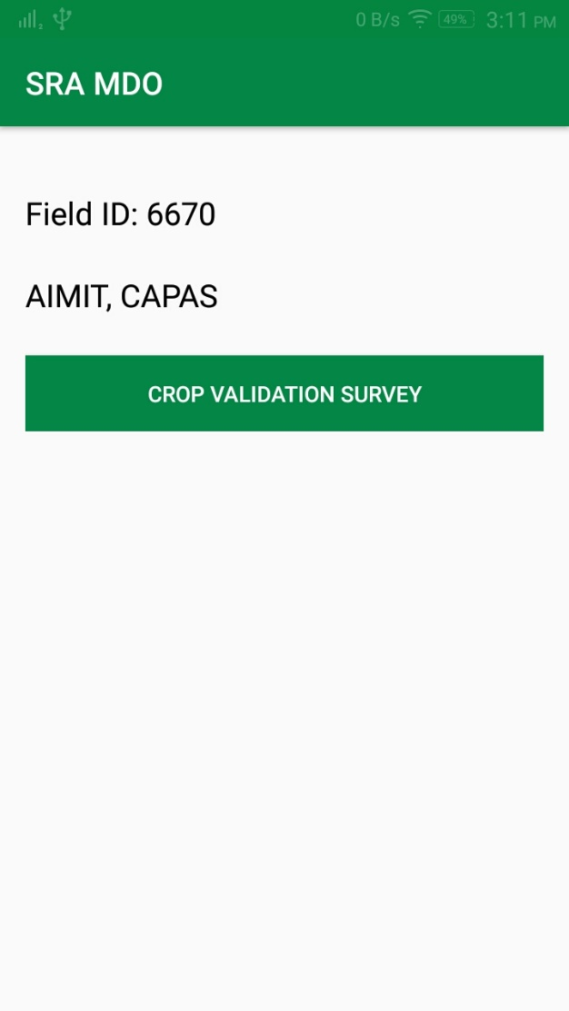

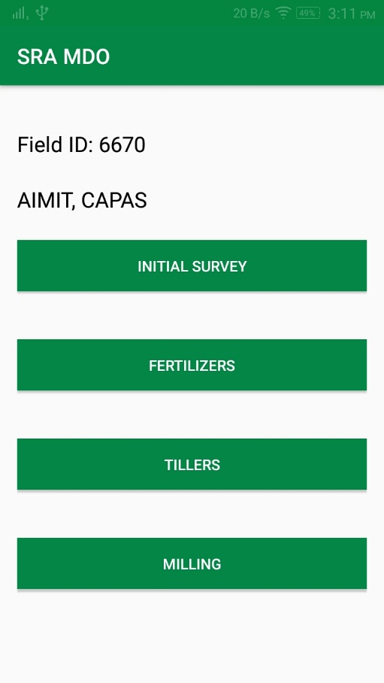

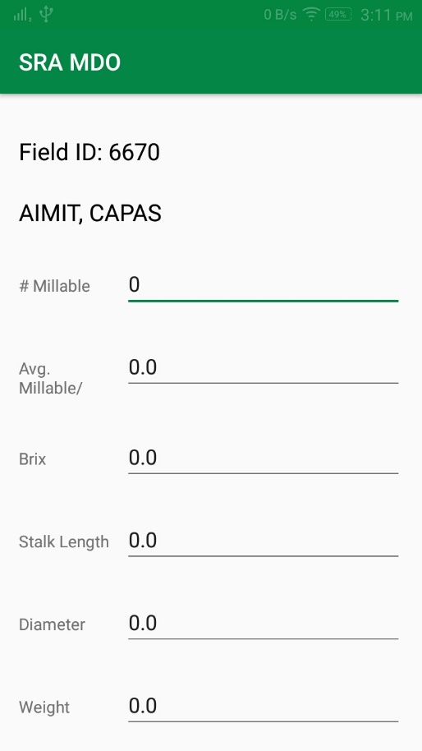

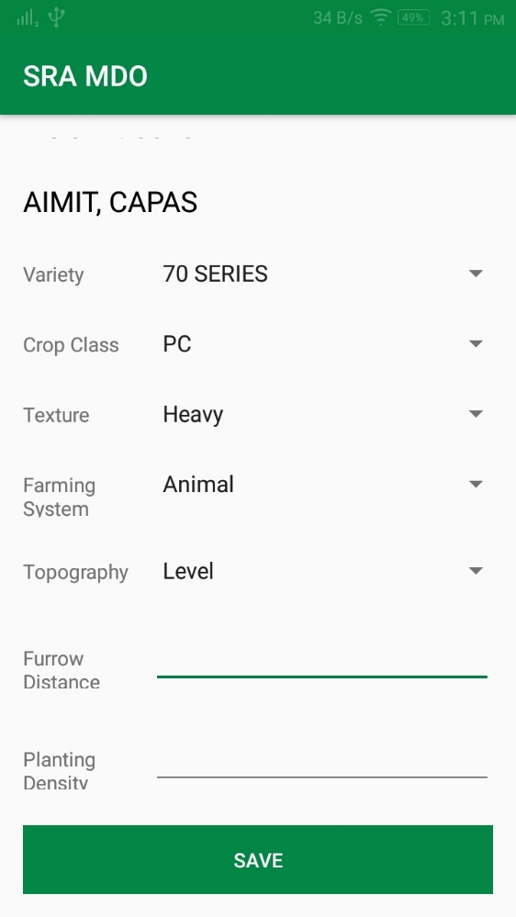

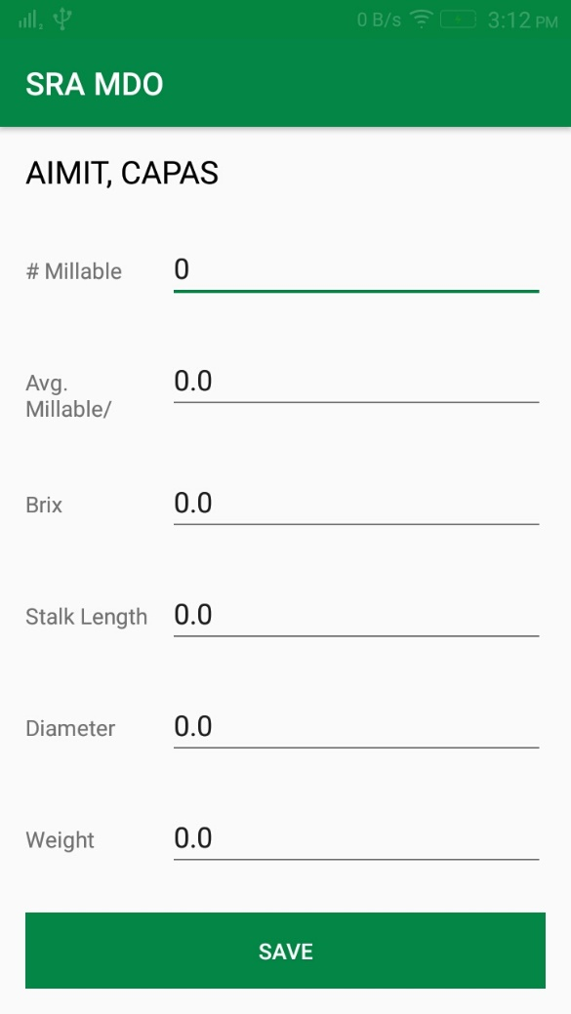

Screen Name : Farmer’s Main Menu

Description : The page contains the main menu for the farmer’s mobile application.

Layout :

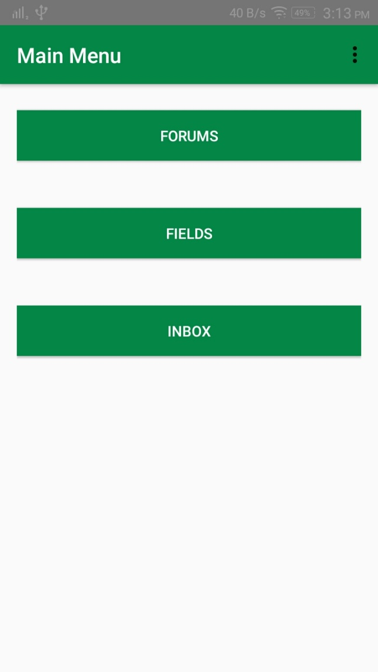

Screen Name : Create Forum Post

Description : The page allows the farmer to submit a forum post.

Layout :

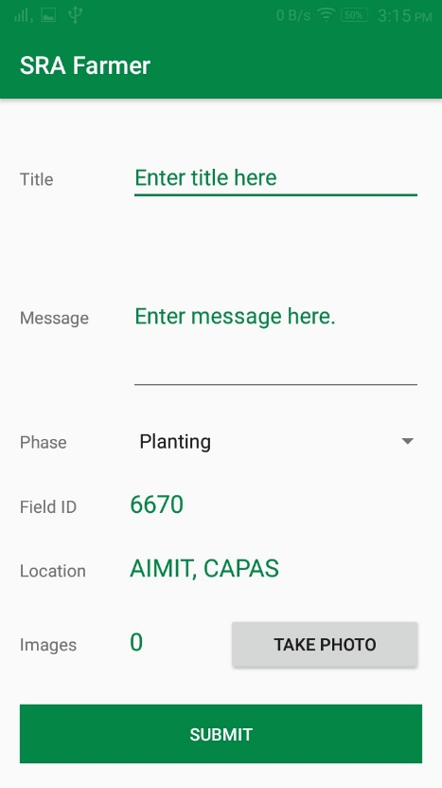

Screen Name : Fields Menu

Description : The page contains the actions available for the fields.

Layout :

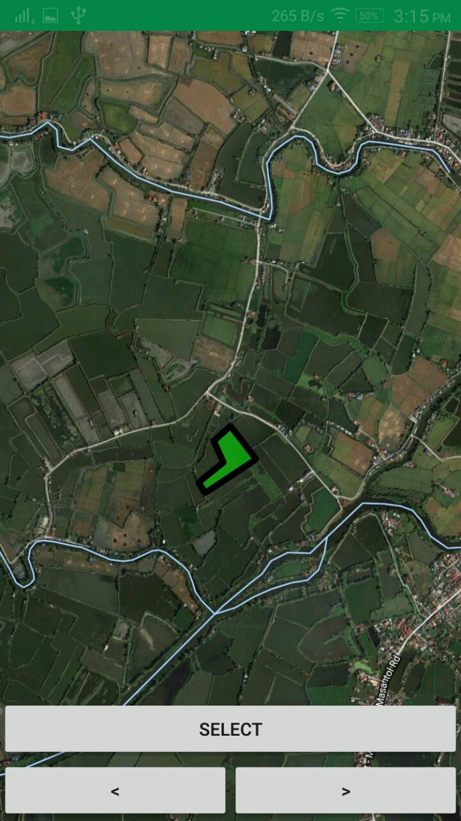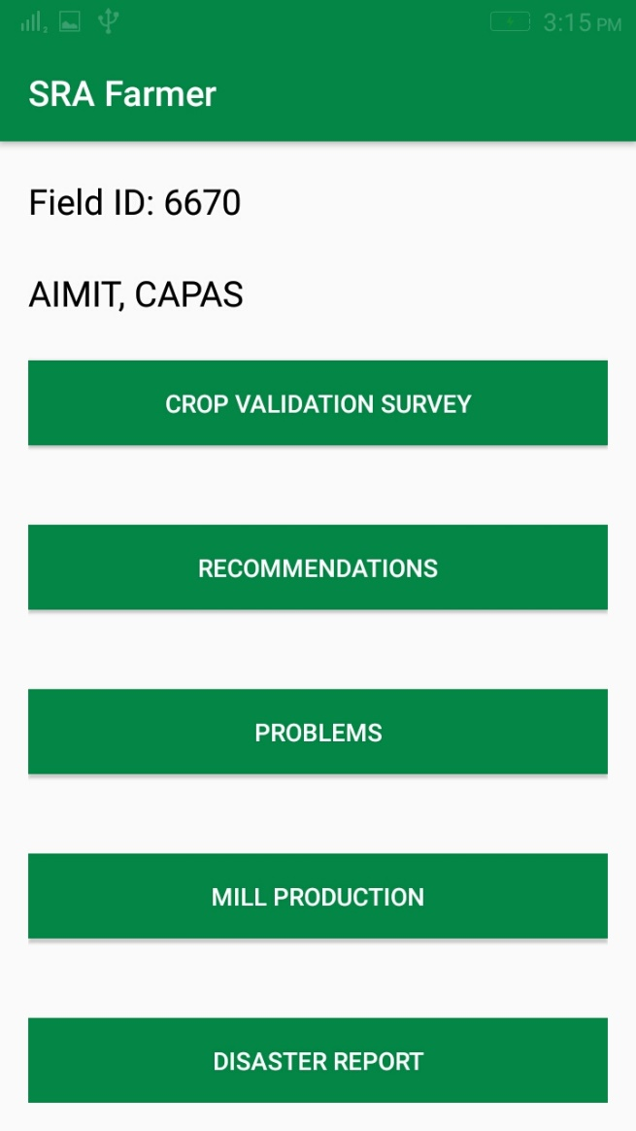

Screen Name : Crop Validation Survey

Description : The page allows the farmer to fill up the CVS.

Layout :

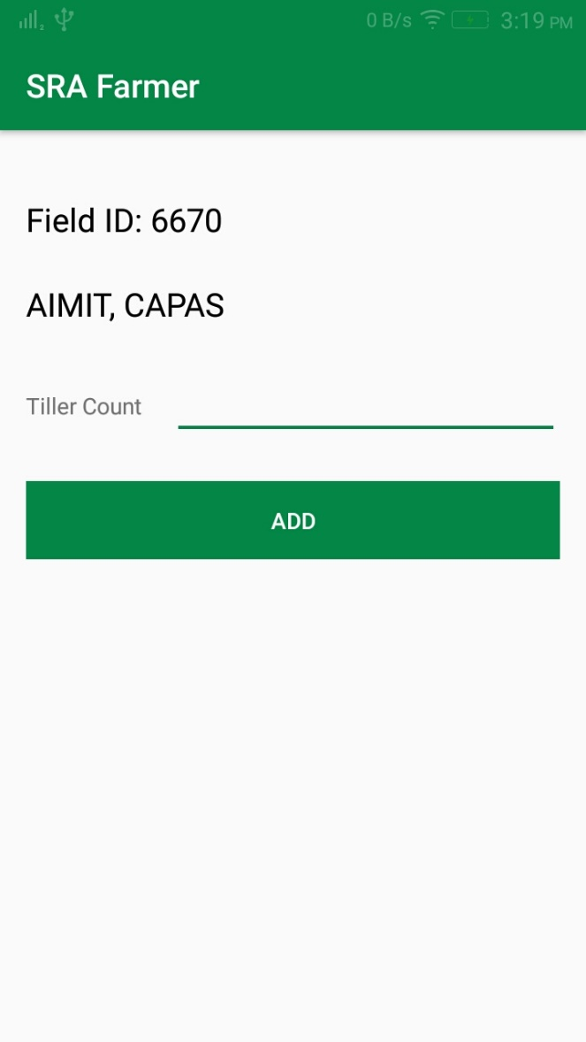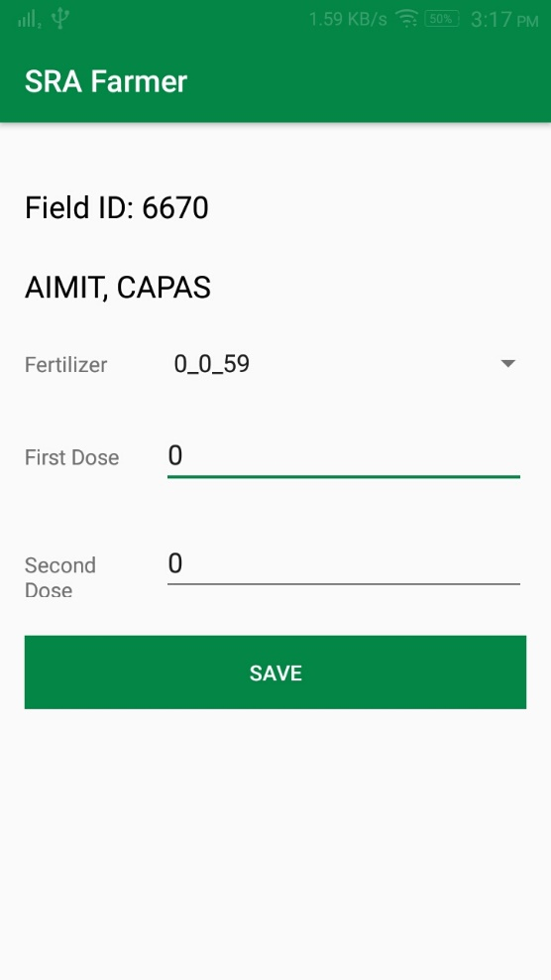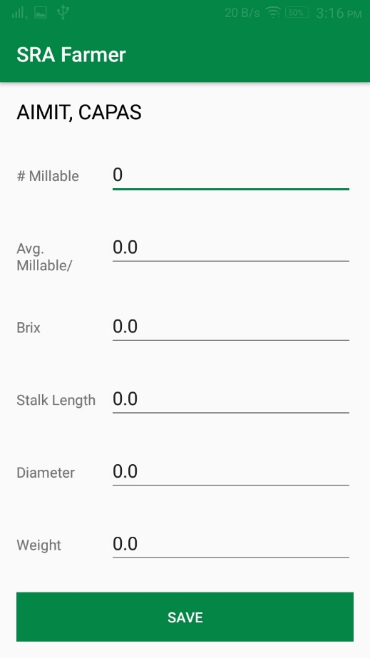

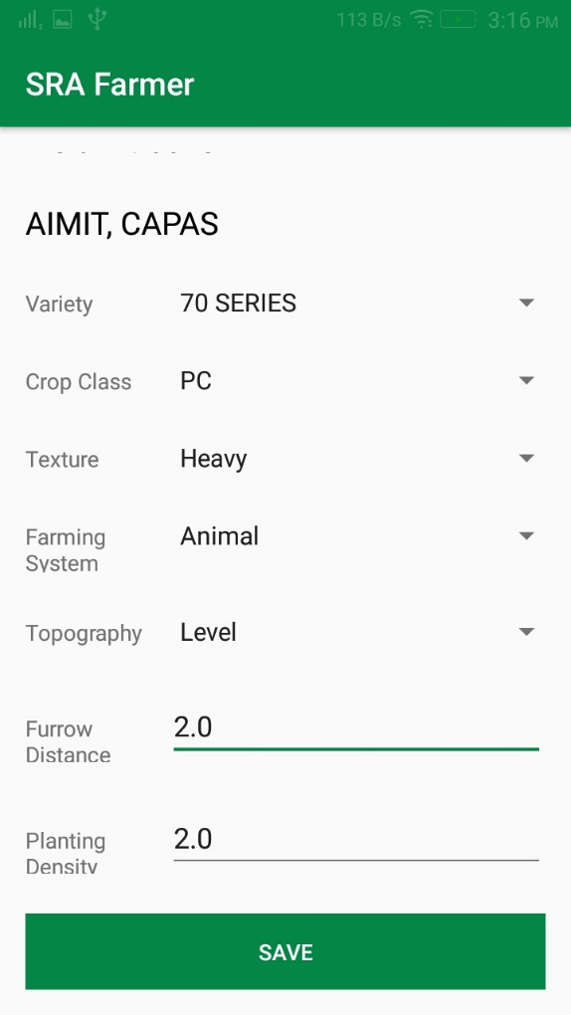

Screen Name : Recommendations List

Description : The page allows the farmer to view all verifying and active recommendations

Layout :

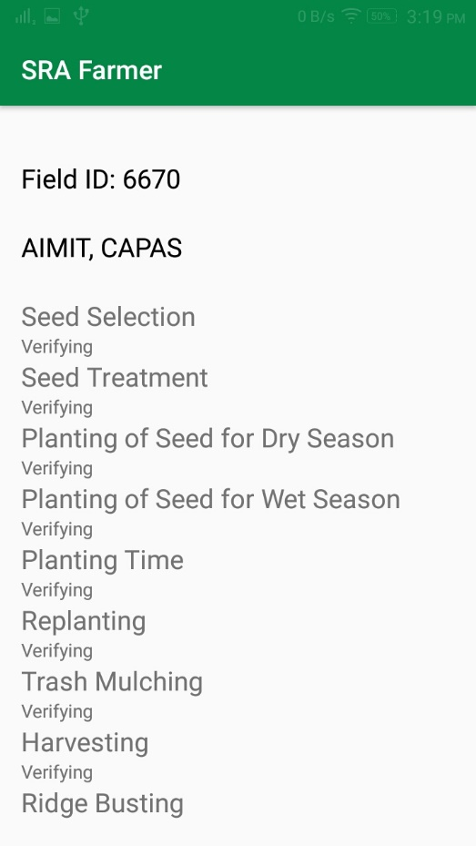

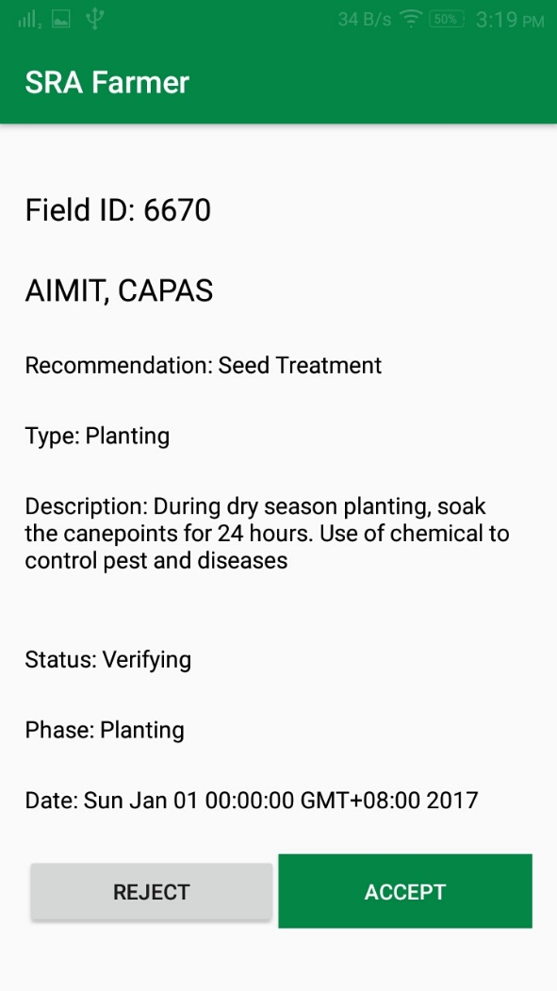

Screen Name : Problem List

Description : The page allows the farmer to view all verifying and active problems

Layout :

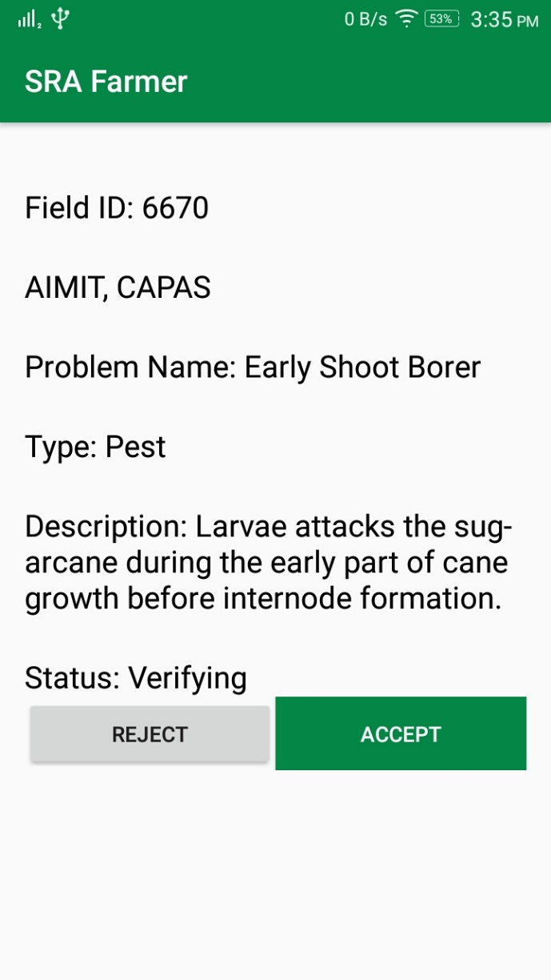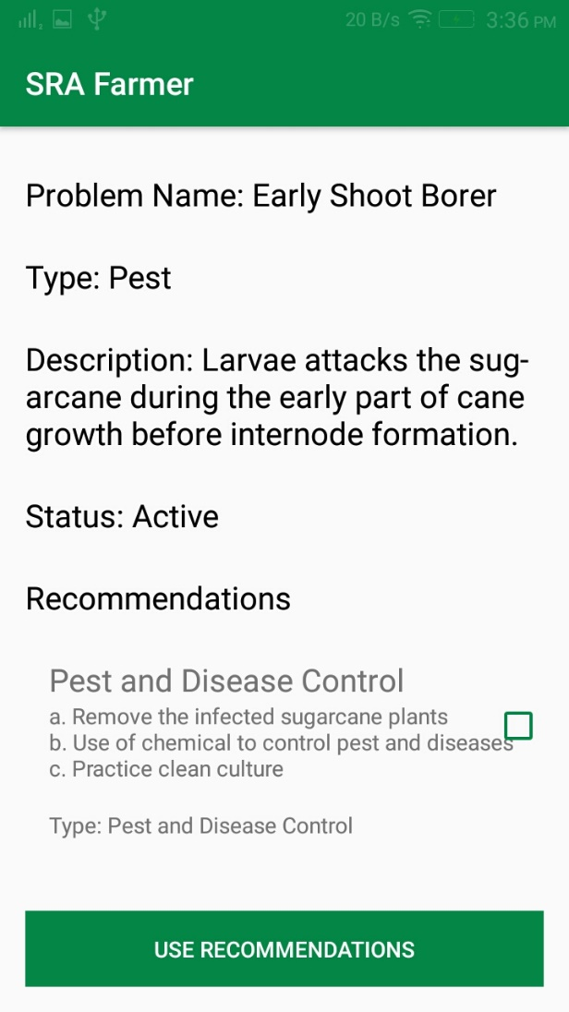

Screen Name : Production

Description : The page allows the farmer to view all verifying and active recommendations

Layout :

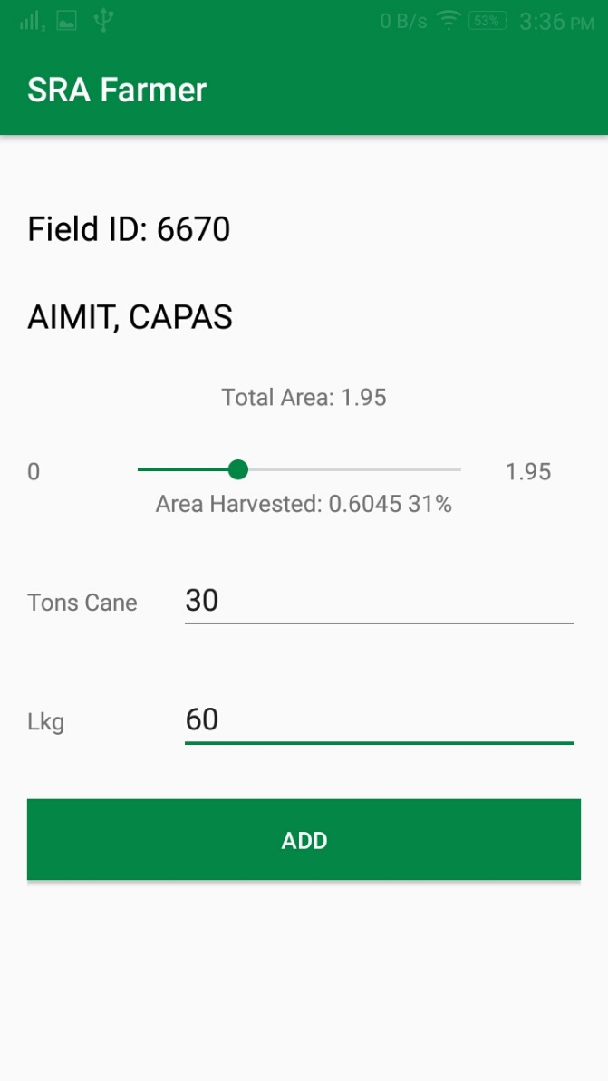

Screen Name : Disaster Report/Survey

Description : The page allows the farmer to submit disaster report and survey

Layout :

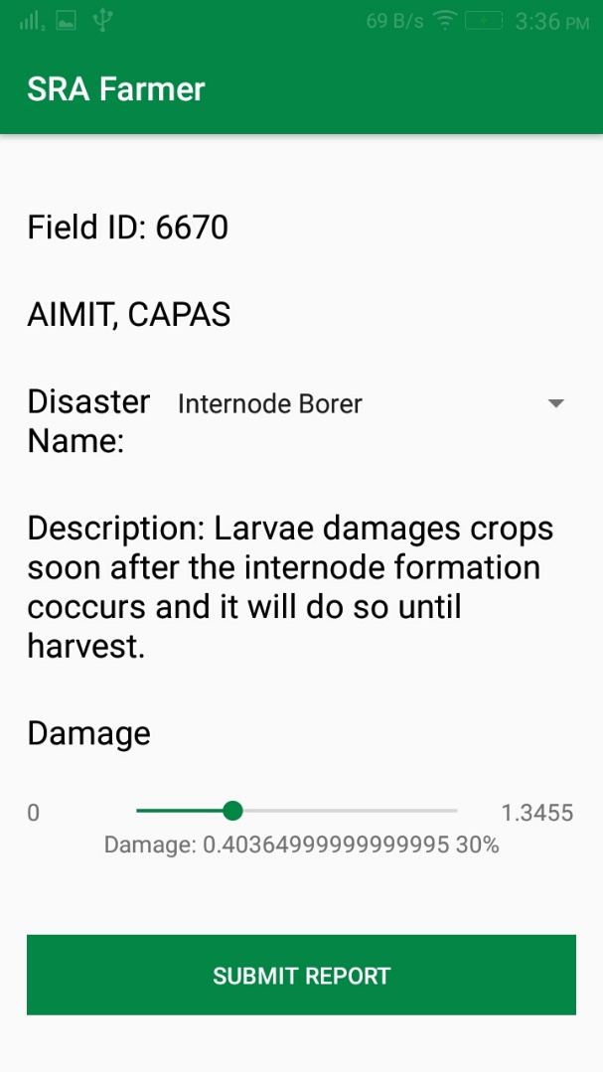

**6.4 Form Specifications**

Form Name : Mill Production

Description : This form is for the production of the farmer’s in area harvested, tons cane, and lkg.

Prepared By : Farmer

Used By : MDO

Volume and Frequency: Every week



Form Name : Disaster Survey/Report

Description : This form is for entering the damage in terms of area harvested of the farmer after a disaster.

Prepared By : Farmer

Used By : Mill Disrict Officer

Volume and Frequency: Every disaster if damage is present



Form Name : Crop Validation Survey

Description : This form allows the farmer to enter the farm details.

Prepared By : Farmer

Used By : Mill District Officer

Frequency: Quarterly or as needed

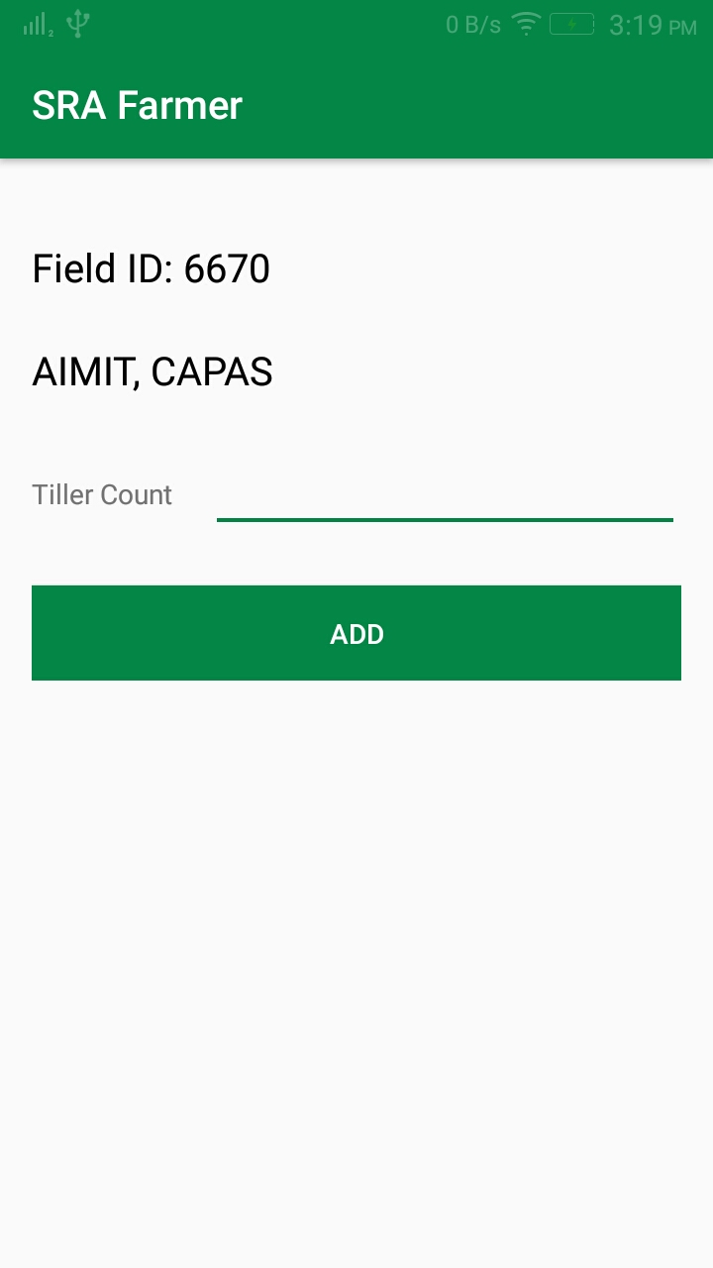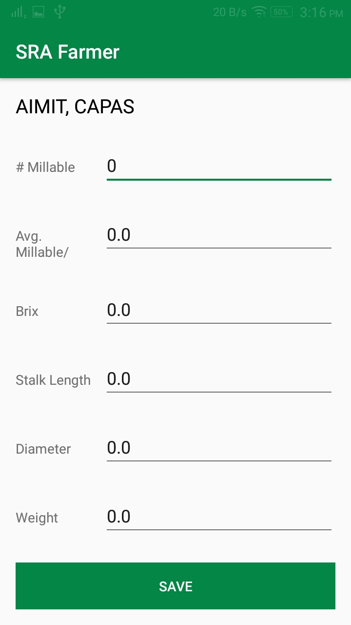

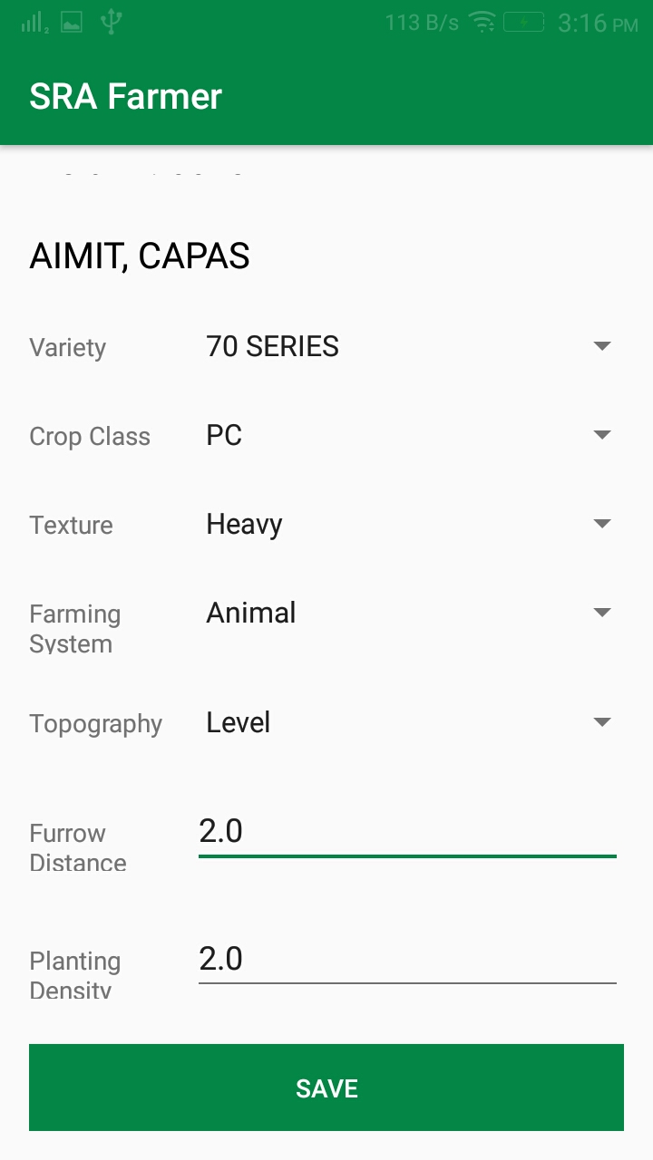

Form Name : Crop Assessment

Description : This form the narrative for the crop assessment report. This is to input the MDO’s analysis for the week based on the weekly production and other external factors.

Prepared By : Mill District Officer

Used By : Board Member

Volume and Frequency: Every week



Form Name : Create New Problem

Description : This form contains the details for the creation of a new problem as well as which phase it is occurring.

Prepared By : Mill District Officer

Used By : Farmer

Volume and Frequency: Every time a post is rejected and when the MDO confirms the post as a problem.

Layout:

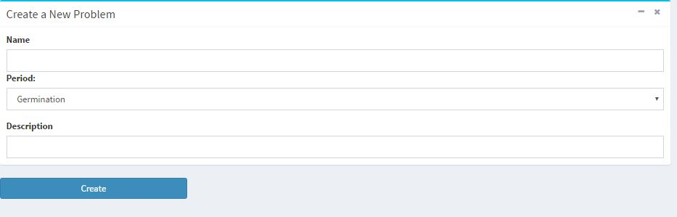

Form Name : Create New Recommendation

Description : This form contains the details of the recommendation

Prepared By : Mill District Officer

Used By : Farmer

Volume and Frequency: Every time a post is rejected and the MDO confirms that a new recommendation is to created.

Layout:

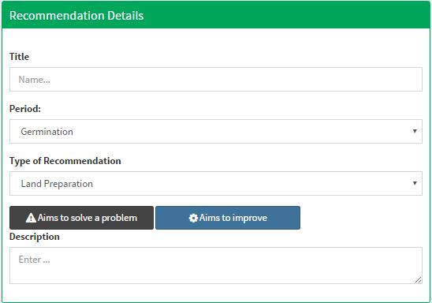

Form Name : Send Other Recommendation

Description : This form contains the details of the recommendation

Prepared By : Mill District Officer

Used By : Farmer

Volume and Frequency: Every time the MDO decides to send other recommendations in his selected farms

Layout:

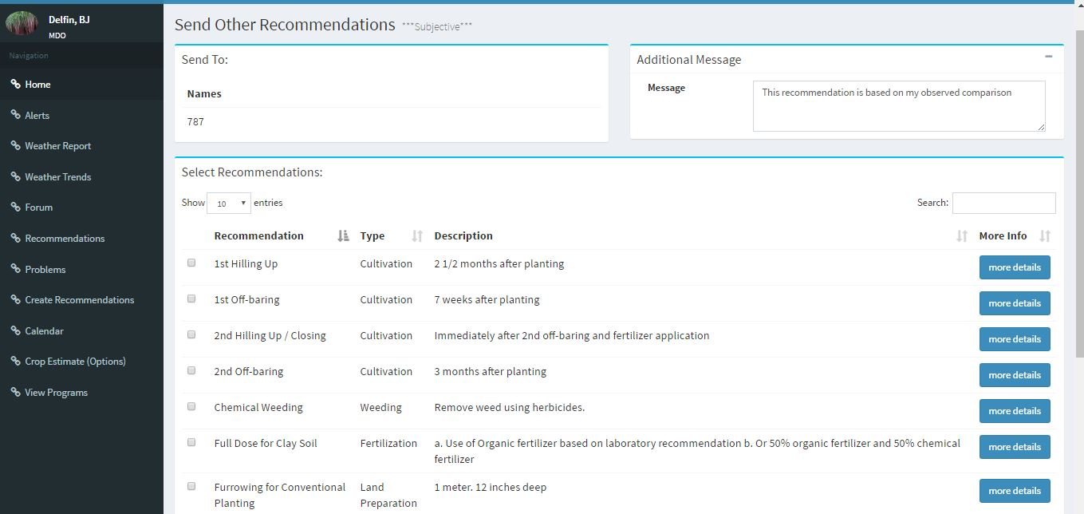

Form Name : Create New Program

Description : This form contains the details for the creation of a new program

Prepared By : Board Members

Used By : Farmer, Board Members, MDO

Layout:







Form Name : Send Alerts

Description : This form contains the details of the alert message

Prepared By : Mill District Officer

Used By : Farmer

Volume and Frequency: Every time there are upcoming disasters such as typhoons.

Layout:

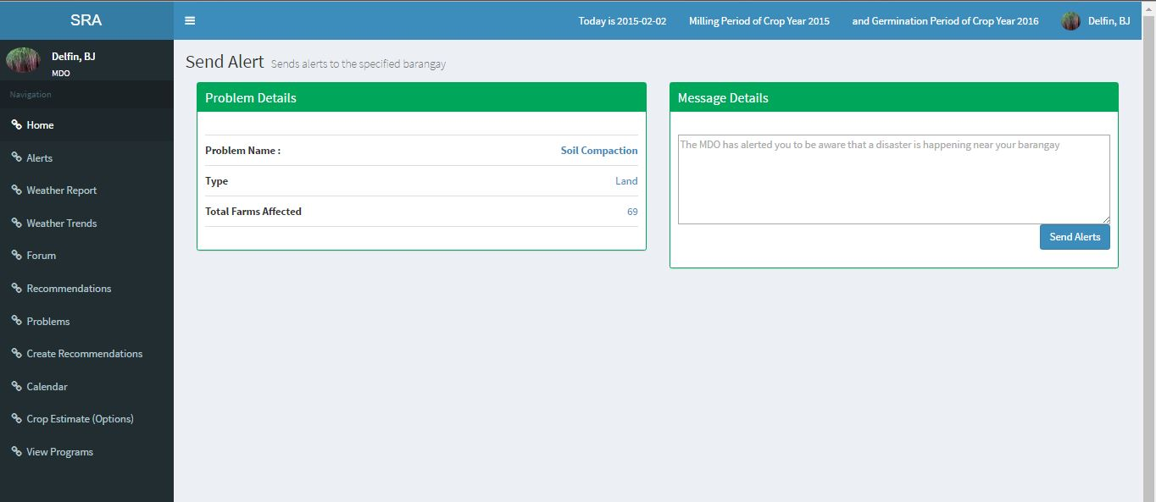

Form Name : Generate Forecast

Description : This form contains the inputs for generating a crop estimate

Prepared By : Mill District Officer and Board Member

Used By : Board Member

Volume and Frequency: Every after milling phase

Layout:

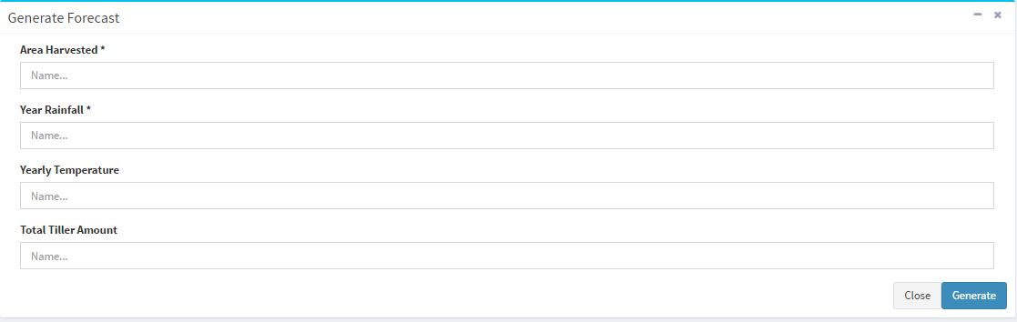

Form Name : Edit crop phases

Description : This form contains dates to be configured in each phase

Prepared By : Mill District Officer

Used By : Farmer

Volume and Frequency: Every crop year

Layout:

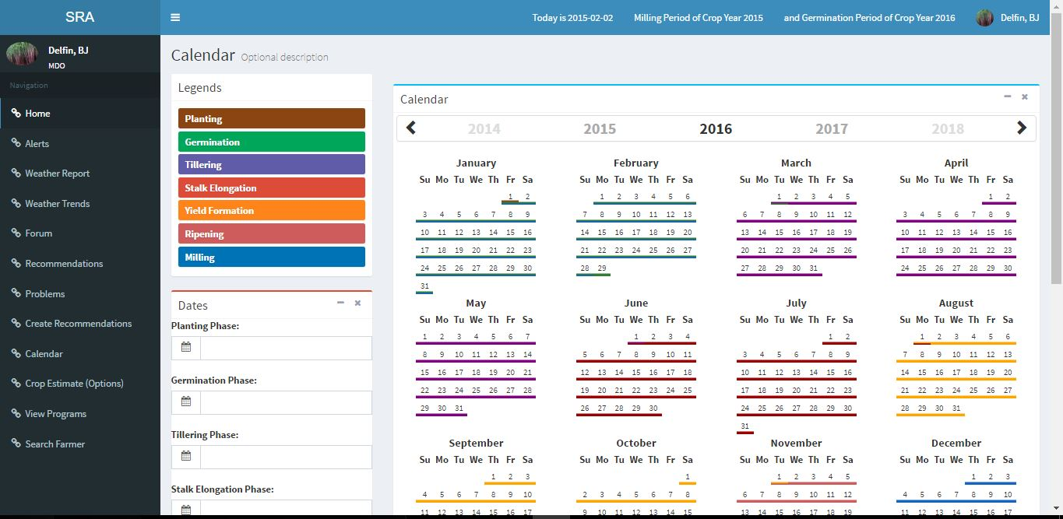



Form Name : Edit Duration

Description : This form contains the setting of duration

Prepared By : Mill District Officer

Used By : Farmer

Layout:

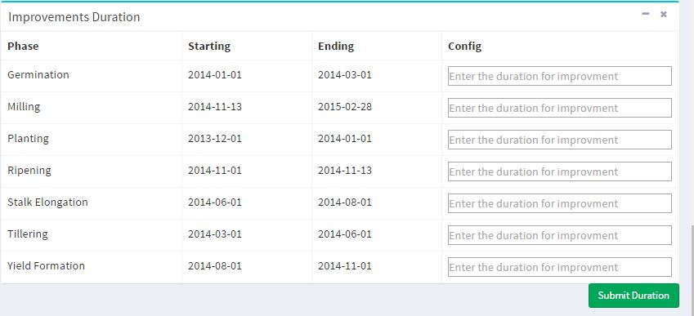

**6.5 Report Specification**

Report Name : Crop Assessment Report

Description : This Report contains the weekly production of the district and the overall analysis of the MDO.

Prepared By : Mill District Officer

Used By : Board Member

Volume and Frequency : Every Week

Layout :

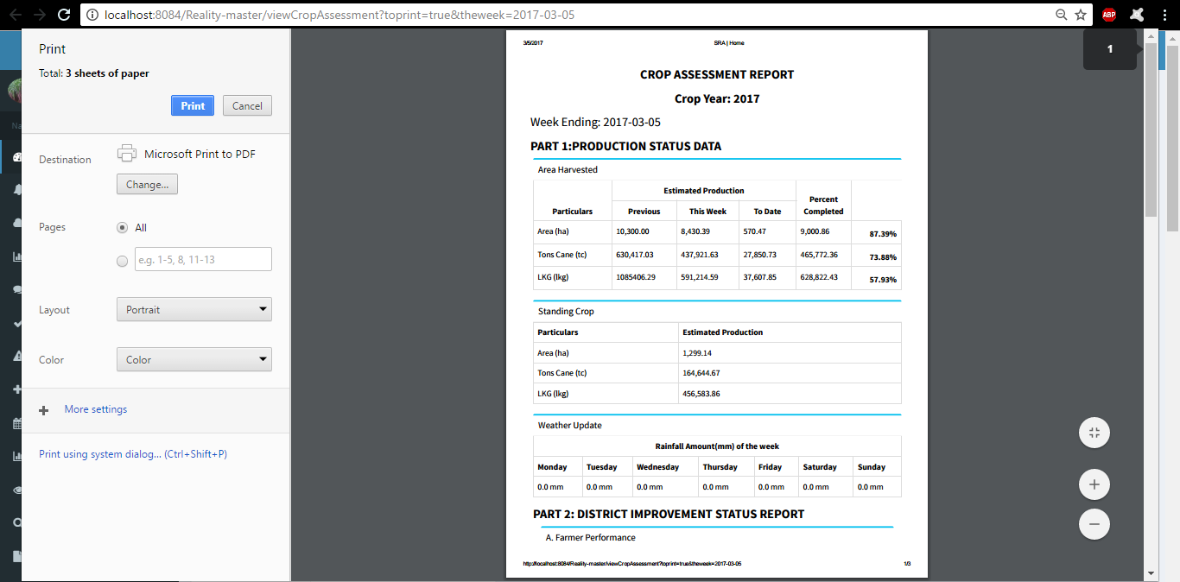

Report Name : Damage Report

Description : This Report contains the damaged area from the reported disaster by the farmer

Prepared By : Farmer

Used By : Mill District Officer

Volume and Frequency : Every disaster occurrence

Layout :

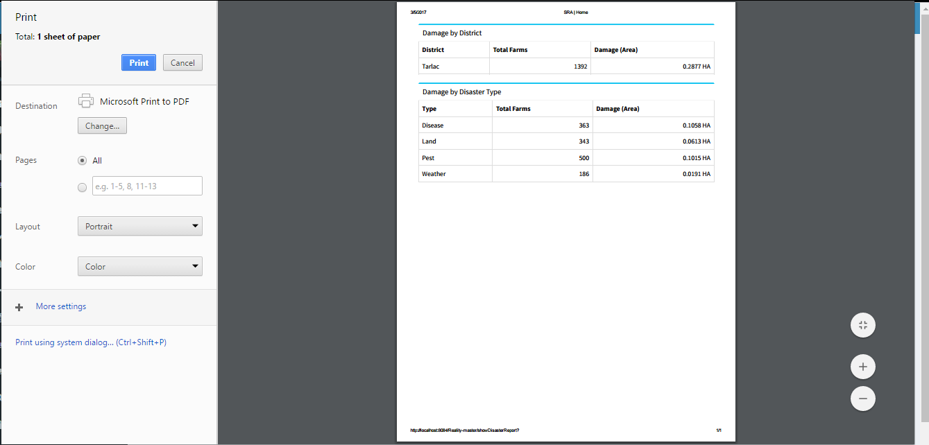

Report Name : Weekly Statistics Report

Description : This Report contains the weekly production of each district

Prepared By: Board Member

Used By : Board Member

Volume and Frequency : Every week

Layout :

